Arthur Birling AO1 read and respond AO2 FSL AO3 Context AO4 SPG/ vocabulary
Key Character vocabulary: |  |  | Attitudes and beliefs:  Capitalist  Every man for himself  Move up the social ladder through business and marriage  Represents the establishment and wants to maintain the status quo  Profit, wealth and status  Against collective responsibility | Involvement in Eva’s Death  Fired her from his company for asking for higher pay and threatening to take strike action along with other workers.  Response to her death: does not feel responsible. Cannot see how his actions led to her death. Believes his actions were justifiable.  Context:  1912, London. Preceded sinking of the Titanic and WW1. Recent violent riots over low pay. Impending miners’ strike. Women don’t yet have the vote and are subservient to men. Recent election of Liberal Party and rise of socialism.
self-promoting  emphatic  dogmatic  domineering  self-confident  uncompromising  opinionated  unscrupulous  condescending  prosperous | authoritative  Insulting Provincial  pompous bullying  obstinate  contemptuous  patronising  cynical  egotistical | magistrate  arrogant  portentous  bigoted  ignorant  affluent  unfair  greedy  proud  selfish
Key Quotes:  “It’s a pity Sir George and – er- Lady Croft can’t be with us.”  “for lower costs and higher prices”  “You can ignore all this silly pessimistic talk.”  “I’m talking as a hard-headed practical man of business”  “there isn’t a chance of war”  “unsinkable, absolutely unsinkable.’’  “look after himself and his own”  “Give us some more light”  “Perhaps I ought to warn you that he’s an old friend of mine”  “I can’t accept any responsibility”  “Nothing to do with you Sheila. Run along.”  “(rather impatiently) Horrid business. But I don’t understand why you should come here.” |  |  | Theatrical devices/ genre  - Stage directions/ Entrances and exits  - Characterisation/ Protagonist  - Actions/ speech/ dialogue/ conflict  - Dramatic irony  - Proleptic irony/ foreshadowing  - Lighting, setting and props  - Relationships between characters  - Expositions/ complication/ climax/ anti-climax/ falling action/ cliff-hangers/ denouement  - Morality play/ naturalism/ Aristotle – unity of time/ place/action/ drawing room drama/ detective story/ well-made play  - Turning points  - Subtext  - pathos | 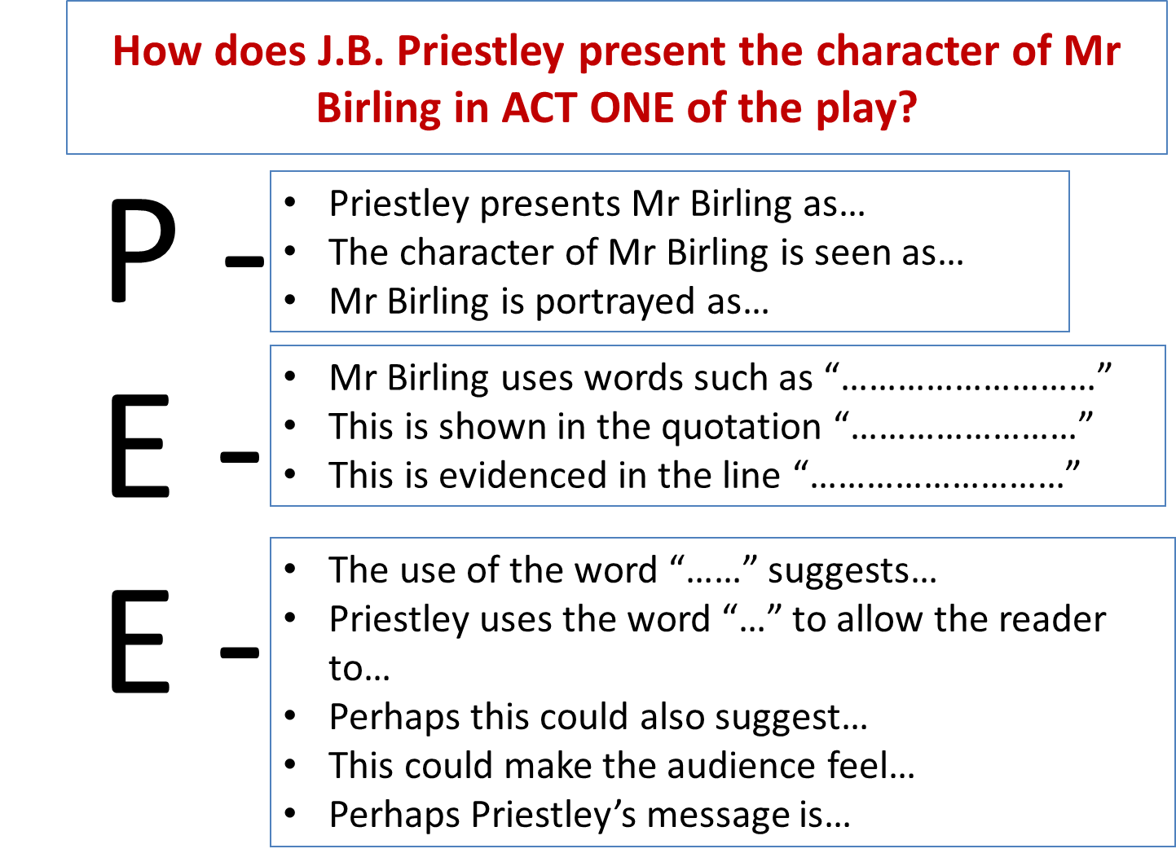  Comically ignorant, Arthur Birling is brought to life on stage through the playwright’s sustained use of dramatic irony. Birling foolishly predicts in his pre-war ignorance that the “Titanic sets sail today...unsinkable, absolutely unsinkable.” The certainty with which he says these words, emphasised through the use of repetition, highlights his self-satisfied ignorance of the realities of the world around him. As the audience know that the Titanic did sink the playwright has successfully undermined Mr Birling so that we are more likely to side with the Inspector once he arrives.
Essay words/ phrases  - Suggests/ implies/ infers  - Demonstrates/ conveys/ presents/ shows/ relays  - Similarly/ in addition/ furthermore/ moreover/ additionally  - In contrast/ however/ on the other hand/ in juxtaposition/ contrastingly |  |  | Literary devices  Simile/ metaphor/ personification/ sensual/ colour imagery  Repetition/ alliteration/ sibilance/ onomatopoeia  Questions/ rhetorical questions  Short sentences  Allegory/ microcosm/ symbolism | Themes and Ideas  - Gender roles  - Social class and establishment  - Responsibility and duty  - Generation gaps/ differences  - Appearance and reality  - Lies and secrecy | 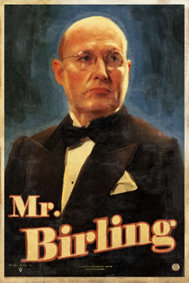

Sheila Birling AO1 read and respond AO2 FSL AO3 Context AO4 SPG/ vocabulary
Key Character vocabulary: |  |  | Attitudes and beliefs:  Has been sheltered from the realities of society by parents  Develops quickly in the play to feel a sense of collective responsibility  Loses faith in her family  Catalyst for Priestley’s socialist views and desire for gender and class equality  Social conscience is awakened  Changes her perspective during the play | Involvement in Eva’s Death  Asked shop manager to have her fired when she was jealous and in a bad mood.  Response to her death: instant reaction is shock and compassion.  When she hears of her involvement, she cries and leaves the room. She feels genuinely guilty and regretful. Distressed by her parents’ responses and her own involvement.  Context:  No woman was allowed to vote. Suffragette movement fighting for women’s rights. Women did not get full voting rights until 1928. Due to the absence of men fighting on the front lines, WW1 gave women opportunities to work in jobs previously reserved for men.
naïve  protected  ignorant  spoilt; selfish  affluent  vain; conceited  indifferent to social hypocrisy  impressionable  childish  possessive | compassionate  considerate  perceptive  repentant  remorseful  distressed  willing, anxious to change  honest  sympathetic  suspicious | Curious  Wiser and more mature  caring
Key Quotes:  “A pretty girl in her early twenties…very pleased with life and rather excited”  “half serious; half playful”  “Sorry Daddy”  “But these girls aren’t cheap labour – they’re people”  “So I’m responsible?”  “I’ll never, never do it again”  “He’s giving us the rope - so that we’ll hang ourselves”  “You fool. He knows!  “We really must stop these silly pretences”  “It frightens me the way you talk” |  |  | Theatrical devices/ genre  - Stage directions/ Entrances and exits  - Characterisation/ Protagonist  - Actions/ speech/ dialogue/ conflict  - Dramatic irony  - Proleptic irony/ foreshadowing  - Lighting, setting and props  - Relationships between characters  - Expositions/ complication/ climax/ anti-climax/ falling action/ cliff-hangers/ denouement  - Morality play/ naturalism/ Aristotle – unity of time/ place/action/ drawing room drama/ detective story/ well-made play  - Turning points  - pathos | Priestley  Sheila offers the audience a beacon of hope for future society in her growing recognition that we are all “people” and we must all take responsibility for our actions and behaviour. Over the course of the play, she increasingly promotes her belief in shared responsibility and acknowledges her own and her family’s guilt in the death of Eva Smith. Her initial self-motivated childishness and vanity is replaced by genuine remorse, resulting in a wiser, more perceptive and compassionate woman. She can now judge her parents and Gerald from a new perspective, but the greatest change has been in herself: her social conscience has been awakened and she is aware of her responsibilities. The Sheila who had a girl dismissed from her job for a trivial reason has vanished forever.
Essay words/ phrases  - Suggests/ implies/ infers  - Demonstrates/ conveys/ presents/ shows/ relays  - Similarly/ in addition/ furthermore/ moreover/ additionally  - In contrast/ however/ on the other hand/ in juxtaposition/ contrastingly |  |  | Literary devices  Simile/ metaphor/ personification/ sensual/ colour imagery  Repetition/ alliteration/ sibilance/ onomatopoeia  Questions/ rhetorical questions  Short sentences  Allegory/ microcosm/ symbolism | Themes and Ideas  Gender roles lies and secrets  Social class and establishment appearance and reality  Responsibility and duty generation gaps/ differences | 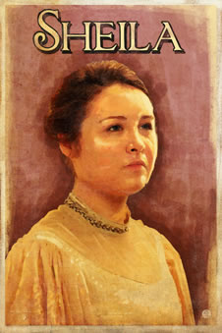
Gerald Croft AO1 read and respond AO2 FSL AO3 Context AO4 SPG/ vocabulary
Key Character vocabulary - not necessarily just in Act One: |  |  | Attitudes and beliefs:  Capitalist – very much a product of his environment  Reactionary – here his beliefs and attitudes contrast with Sheila’s more responsible outlook on society  Seems to genuinely love for love’s sake, not caring for social status through business/marriage in this respect  Represents the establishment, but appears to need to prove to older generation that he is a worthy successor  Profit, wealth and belief in the status quo which created him; lives in an era when people ‘knew their place’. | Involvement in Eva’s Death: (Not shown in Act One)  Although an argument can be made for Gerald initially stepping in to protect Eva out of compassion, it is his later (inevitable) rejection of her which sends her further down the road to ruin.  Response to her death: Seems genuinely saddened and shocked by Eva’s death. (It was not uncommon for Edwardian men of Gerald’s class to have mistresses – as long as no scandal resulted.)  Context:  1912, London. Preceded sinking of the Titanic and WW1. Recent violent riots over low pay. Impending miners’ strike. Women don’t yet have the vote and are subservient to men. Recent election of Liberal Party and rise of socialism. 1911 Mansion House speech from Lloyd George. Publication of ‘The Living Wage’ by Philip Snowden in 1912.
Self-promoting  Double standards  Dogmatic  Heir to dynasty  Self-confident  Entrenched  Opinionated  Polite and relaxed  condescending | Self-assured  Sycophantic  Worldly-wise  Pompous  Self-serving  Charming  Politic  Secretive  Insensitive | Arrogant  Biased  Bigoted  Ignorant  Affluent  Privileged  Unfaithful  Proud Mature
Key Quotes:  ‘...easy, well-bred man about town.’  “You’re just the kind of son-in-law I always wanted.”  “...except for all last summer, when you never came near me, and I wondered what had happened to you.”  “I was awfully busy at the works at that time.”  “Thank you. And I hope I can make you as happy as you deserve to be.”  (About Birling’s firing of Eva Smith): “I know we’d have done the same thing. Don’t look at me like that Sheila.”  “After all, y’know, we’re respectable citizens and not criminals.”  “I didn’t......All right, I knew her. Let’s leave it at that.....I’m sorry, Sheila. But it was all over and done with last summer. I hadn’t set eyes on the girl for at least six months. I don’t come in to this suicide business....don’t say anything to the inspector...We can keep it from him.” |  |  | Theatrical devices/ genre  - Stage directions/ Entrances and exits  - Characterisation/ Protagonist  - Actions/ speech/ dialogue/ conflict  - Dramatic irony  - Proleptic irony/ foreshadowing  - Lighting, setting and props  - Relationships between characters  - Expositions/ complication/ climax/ anti-climax/ falling action/ cliff-hangers/ denouement  - Morality play/ naturalism/ Aristotle – unity of time/ place/action/ drawing room drama/ detective story/ well-made play  - Turning points  - Subtext  - pathos | How does Priestley present the character of Gerald Croft in Act One of the play?  Like his prospective father-in-Law, Mr. Birling, Gerald’s unquestioning adherence to the Capitalist system which has made his family their fortune is revealed on stage through the playwright’s sustained use of dramatic irony. Gerald’s almost obsequious “I believe you’re right Sir” and “I’ll bet you did” shows him to be in total agreement to Birling’s unconscionable views. Gerald’s privileged background and self-assured manner and the certainty with which he says these words echoes Birling’s self-satisfied ignorance of the realities of the changing world around them. Gerald’s similarly arrogant assertions – and his secretive nature – do not endear the reader/audience to him. The playwright uses him to show that that such views will almost certainly be maintained by the next generation. As the audience is increasingly made to feel uncomfortable by Birling’s arrogance, when Gerald agrees with him so enthusiastically, this disdain is transferred to Gerald too.
Essay words/ phrases  - Suggests/ implies/ infers  - Demonstrates/ conveys/ presents/ shows/ relays  - Similarly/ in addition/ furthermore/ moreover/ additionally  - In contrast/ however/ on the other hand/ in juxtaposition/ contrastingly |  |  | Literary devices  - Simile/ metaphor/ personification/ sensual/ colour imagery  - Repetition/ alliteration/ sibilance/ onomatopoeia  - Questions/ rhetorical questions  - Short sentences  - Allegory/ microcosm/ symbolism | Themes and Ideas  - Gender roles  - Social class and establishment  - Responsibility and duty  - Generation gaps/ differences  - Appearance and reality  - Lies and secrecy | 

