How long is a piece of string?
It's usually not possible to travel in a straight line between two points on a map. If you're following a road or footpath, it can change direction many times to avoid things like woods and rivers.

However, there are still simple ways of measuring the actual distance you will need to travel between two points. One of them is to use a piece of string.

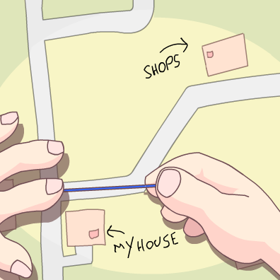
Step 1
Take a length of string – it's best to take one longer than you think you'll need – and place one end on your starting point.

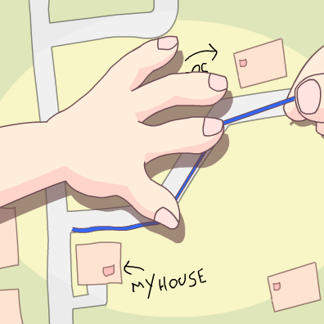
Step 2
Now carefully lay the string along the road or path you know you're going to use, following the curves as closely as you can. When you reach your finishing point, mark it on your string with a pen.

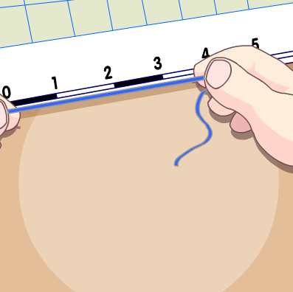
Step 3
Now that you have your distance from the map, you can straighten out your string and place it against the scale bar to find out how far you will actually be travelling.

On the paper's edge
Another method of measuring distance is to take a sheet of paper and place the corner of a straight edge on your starting point. Now pivot the paper until the edge follows the route that you want to take.

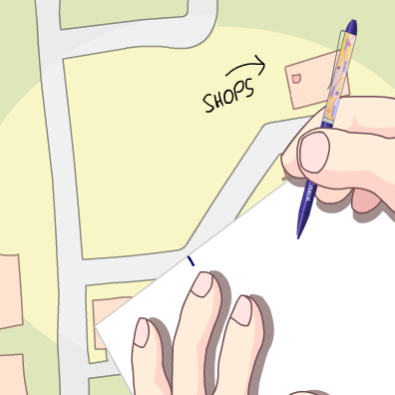
Step 1
Every time the route disappears or moves away from the straight edge of your paper, make a small mark on the edge and pivot the paper so the edge is back on course.

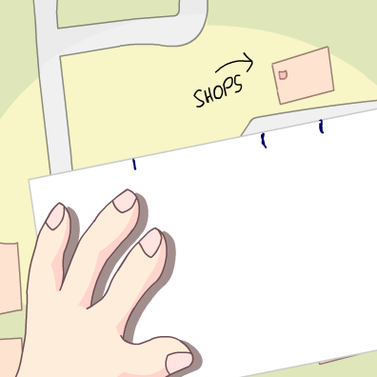
Step 2
Repeat this process until you reach your destination.

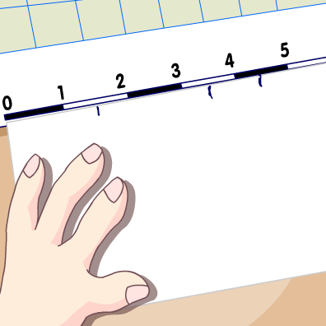
Step 3
You should be left with a series of marks along the edge of your paper. You can now place the sheet against the scale bar on your map.

The last mark you made will tell you the real distance you need to travel.

