How do we show height on maps?
Contour lines are a map’s way of showing you how high the land is. They join together places of the same height and form patterns that help us to imagine what the land actually looks like.

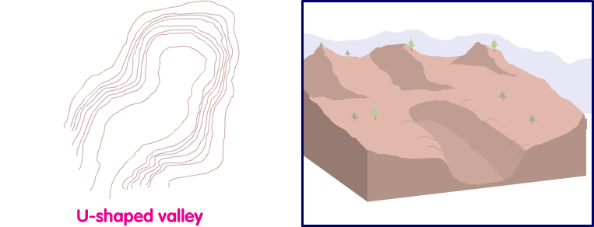

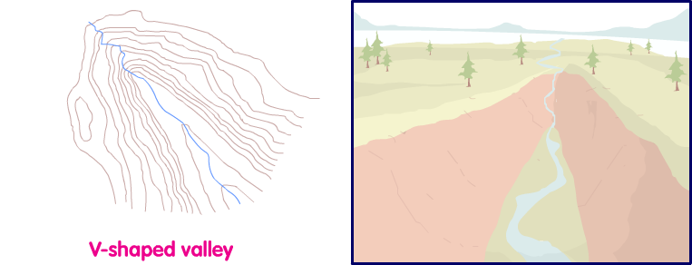

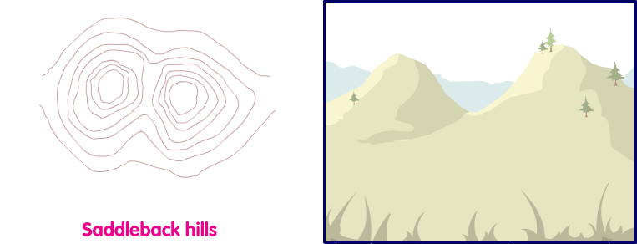

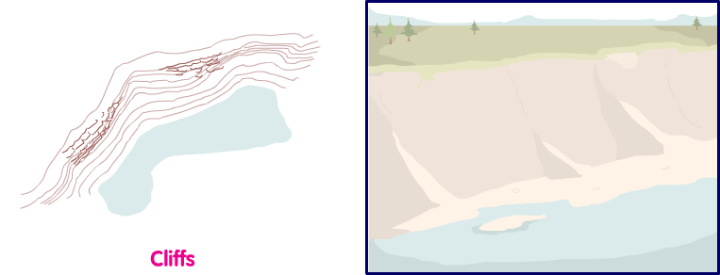

‘Naismith’s rule’
Remember that the closer together the contour lines are, the steeper the land. Contour lines that are wide apart show us that the land is flatter.

When you're travelling across steep landscapes (where contour lines are very close together) it will add time on to your journey.

Naismith said that you should allow an extra minute of walking time for every 10 metres of height that you climb.

Contour lines are usually drawn at 10 metre intervals on a 1:50 000 scale map and at 5 metre intervals on a 1:25 000 scale map.

