Quick reference guide
This sheet is a quick guide to grid references. It should help you when you are asked to find something on a map, such as a town, or even an individual building.

The grid lines on an Ordnance Survey map are called eastings (along the corridor) and northings (up the stairs).

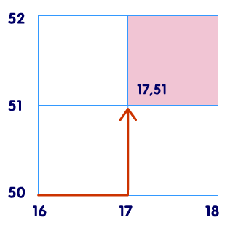
Four-figure grid references
Each square has a grid reference which you get by putting together the numbers of the easting and northing that cross in its bottom left hand corner.

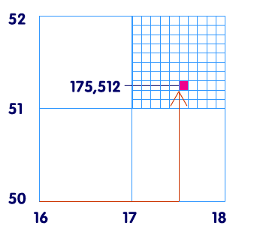

Six-figure grid references
In your head, you should be able to divide all sides of the square into ten equal sections. By doing this, you can pinpoint locations within the square – these are called six-figure grid references.

