What is scale?
Scale is what makes map drawing possible. It takes real life things and reduces them in size many times so they can be shown on a map.

Every map has a scale printed on the front and you should always check this figure before you start reading it. It will tell you how much smaller the area shown on the map is compared to the same area in real life.

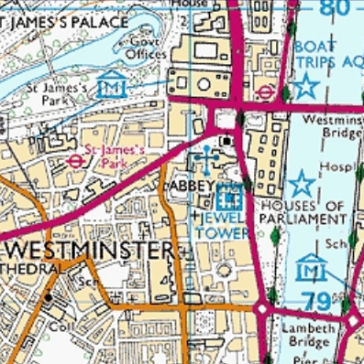
1:25 000
This means that every one unit of measurement on the map (like a centimetre) is the same as 25 000 of those units (in this case 25 000 cm or 250 metres) in real life.

Ordnance Survey produces maps drawn to many different scales, depending on what people want to use them for.

© Crown Copyright 2002: Explorer™ 161

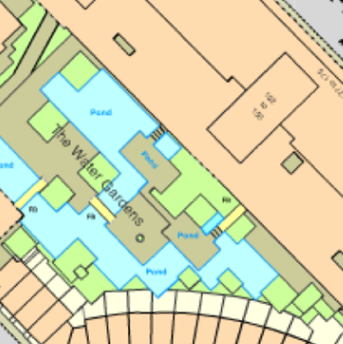
Large scale maps
Large scale maps are better for showing individual buildings in detail because they only cover a small area of land.

© Crown Copyright 2002: MasterMap®

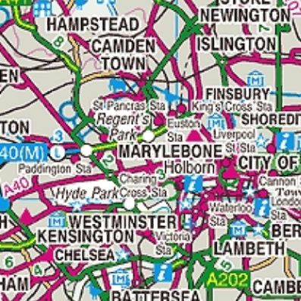
Small scale maps
Small scale maps are ideal for travelling either by car or walking because they cover large areas of land.

© Crown Copyright 2002: OS Travel Map – Road No. 5

Other maps are drawn to a smaller scale and show smaller amounts of detail, but cover a wider area. These maps are often used for planning long walks and drives.

It might help you to remember that the larger the number in the scale, the smaller the scale of the map will be.

Scale summary
Ordnance Survey produces different maps for different uses. Each of these uses normally requires a different scale.

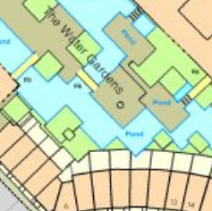

1:1250
OS MasterMap®
Ideal for architects

© Crown Copyright 2002: OS MasterMap®

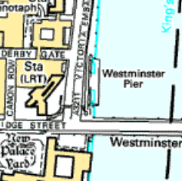

1:10 000

Landplan®
Ideal for town developers

© Crown Copyright 2002: Landplan®

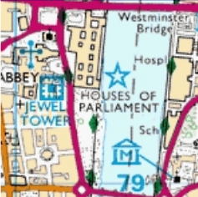

1:25 000
Explorer™
Ideal for outdoor activities

© Crown Copyright 2002: Explorer™ 161

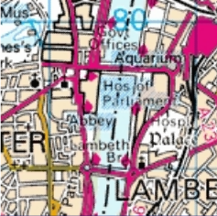

1:50 000
Landranger®
Ideal for planning a day out

© Crown Copyright 2002: Landranger ® 176

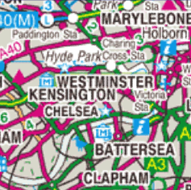

1:250 000

OS Travel Map – Road
Ideal for motorists, and long journeys

© Crown Copyright 2002:
Travel Map – Road No. 5

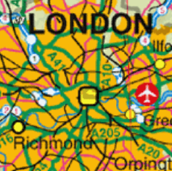

1:1 000 000
MiniScale®
Ideal for seeing the whole
country at a glance

© Crown Copyright 2002: MiniScale®

