**Source A: 20th century nonfiction**

Extract taken from Bill Bryson’s travel book *Notes from a Small Island*.

Blackpool – and I don’t care how many times you hear this, it never stops being amazing – attracts more visitors every year than Greece and has more holiday beds than the whole of Portugal. It consumes more chips per capita than anywhere else on the planet. (It gets through forty acres of potatoes a day.) It has the largest concentration of roller-coasters in Europe. It has the continent's second most popular tourist attraction, the forty-two-acre Pleasure Beach, whose 6.5 million annual visitors are exceeded in number only by those going to the Vatican. It has the most famous illuminations. And on Friday and Saturday nights it has more public toilets than anywhere else in Britain; elsewhere they call them doorways.

Whatever you may think of the place, it does what it does very well - or if not very well at least very successfully. In the past twenty years, during a period in which the number of Britons taking traditional seaside holidays has declined by a fifth, Blackpool has increased its visitor numbers by 7 per cent and built tourism into a £250-million-a-year industry - no small achievement when you consider the British climate, the fact that Blackpool is ugly, dirty and a long way from anywhere, that its sea is an open toilet, and its attractions nearly all cheap, provincial and dire.

It was the illuminations that had brought me there. I had been hearing and reading about them for so long that I was genuinely keen to see them. So, after securing a room in a modest guesthouse on a back street, I hastened to the front in a sense of some expectation. Well, all I can say is that Blackpool's illuminations are nothing if not splendid, and they are not splendid. There is, of course, always a danger of disappointment when you finally encounter something you have wanted to see for a long time, but in terms of letdown it would be hard to exceed Blackpool's light show. I thought there would be lasers sweeping the sky, strobe lights tattooing the clouds and other gasp-making dazzlements. Instead there was just a rumbling procession of old trams decorated as rocket ships or Christmas crackers, and several miles of paltry decorations on lampposts. I suppose if you had never seen electricity in action, it would be pretty breathtaking, but I'm not even sure of that. It all just seemed tacky and inadequate on rather a grand scale, like Blackpool itself.

What was no less amazing than the meagreness of the illuminations were the crowds of people who had come to witness the spectacle. Traffic along the front was bumper to bumper, with childish faces pressed to the windows of every creeping car, and there were masses of people ambling happily along the spacious promenade. At frequent intervals hawkers sold luminous necklaces and bracelets or other short-lived diversions, and were doing a roaring trade. I read somewhere once that half of all visitors to Blackpool have been there at least ten times. Goodness knows what they find in the place. I walked for a mile or so along the prom, and couldn't understand the appeal of it - and I, as you may have realized by now, am an enthusiast for tat. Perhaps I was just weary after my long journey from Porthmadog, but I couldn't wake up any enthusiasm for it at all. I wandered through brightly lit arcades and peered in bingo halls, but the festive atmosphere that seemed to seize everyone failed to rub off on me. Eventually, feeling very tired and very foreign, I retired to a fish restaurant on a side-street, where I had a plate of haddock, chips and peas, and was looked at like I was some kind of southern pansy when I asked for tartare sauce, and afterwards took yet another early night.

**Source B: 19th century literary nonfiction**

Extract taken from Charles Dickens’ travelogue *Pictures from Italy.*

Pleasant Verona! With its beautiful old palaces, and charming country in the distance, seen from terrace walks, and stately, balustraded galleries*. With its Roman gates, still spanning the fair street, and casting, on the sunlight of to-day, the shade of fifteen hundred years ago. With its marble-fitted churches, lofty towers, rich architecture, and quaint old quiet thoroughfares, where shouts of Montagues and Capulets* once resounded. […] With its fast-rushing river, picturesque old bridge, great castle, waving cypresses, and prospect so delightful, and so cheerful! Pleasant Verona!

In the midst of it, in the Piazza di Bra — a spirit of old time among the familiar realities of the passing hour — is the great Roman Amphitheatre*. So well preserved, and carefully maintained, that every row of seats is there, unbroken. Over certain of the arches, the old Roman numerals may yet be seen; and there are corridors, and staircases, and subterranean* passages for beasts, and winding ways, above ground and below, as when the fierce thousands hurried in and out, intent upon the bloody shows of the arena. Nestling in some of the shadows and hollow places of the walls, now, are smiths with their forges, and a few small dealers of one kind or other; and there are green weeds, and leaves, and grass, upon the parapet. But little else is greatly changed.

When I had traversed all about it, with great interest, and had gone up to the topmost round of seats, and turning from the lovely panorama closed in by the distant Alps, looked down into the building, it seemed to lie before me like the inside of a prodigious* hat of plaited straw, with an enormously broad brim and a shallow crown; the plaits being represented by the four-and-forty rows of seats. The comparison is a homely and fantastic one, in sober remembrance and on paper, but it was irresistibly suggested at the moment, nevertheless.

[…]

I walked through and through the town all the rest of the day, and could have walked there until now, I think. In one place, there was a very pretty modern theatre, where they had just performed the opera (always popular in Verona) of Romeo and Juliet. In another there was a collection, under a colonnade*, of Greek, Roman, and Etruscan remains, presided over by an ancient man who might have been an Etruscan relic himself; for he was not strong enough to open the iron gate, when he had unlocked it, and had neither voice enough to be audible when he described the curiosities, nor sight enough to see them: he was so very old. In another place, there was a gallery of pictures: so abominably bad, that it was quite delightful to see them mouldering away. But anywhere: in the churches, among the palaces, in the streets, on the bridge, or down beside the river: it was always pleasant Verona, and in my remembrance always will be.

*Glossary

balustraded gallery = a type of balcony

Montagues and Capulets = the two families from Shakespeare’s *Romeo and Juliet*, which is set in Verona

Amphitheatre = an open, circular building with a central space for the presentation of dramatic or sporting events surrounded by tiers of seats for spectators

subterranean = underground

prodigious = impressive, extraordinary

colonnade = a type of walkway with a row of columns supporting a roof

1. Look at the image below. Note down what you can see and what the message (inference) is.

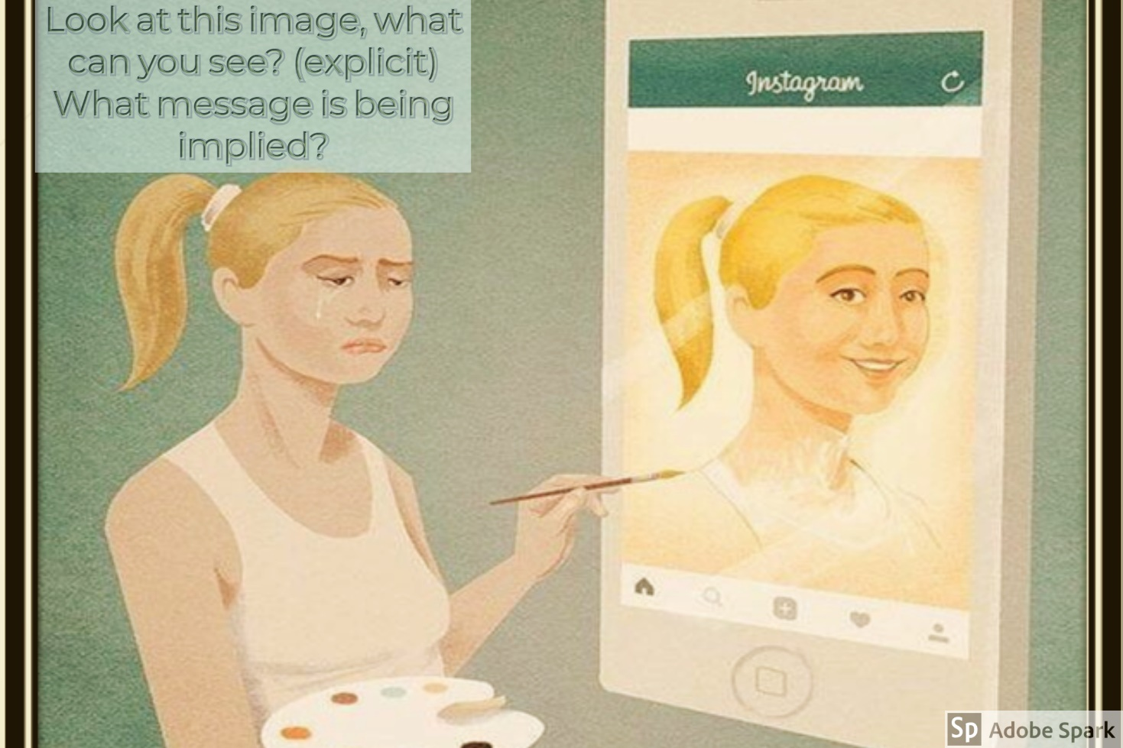

1. Read the 2 articles above.
2. Complete the Venn diagram of similarities and differences between the 2 articles

BLACKPOOL VERONA

1. **Write an answer to the question below. Spend NO LONGER than 10 minutes on it.** Use 2 points from each side of the Venn diagram.

**Remember, you are NOT analysing language used. Just inference and summarising the differences.**

**Q2.** You need to refer to **Source A** and **Source B** for this question.

Use details from **both** sources. Write a summary of the differences between Blackpool and Verona.

**[8 marks]**

______________________________________________________________________________________________________________________________________________________________________________________________________________________________________________________________________________________________________________________________________________________________________________________________________________________________________________________________________________________________________________________________________________________________________________________________________________________________________________________________________________________________________________________________________________________________________________________________________________________________________________________________________________________________________________________________________________________________________________________________________________________________________________________________________________________________________________________________________________________________________________________________________________________________________

___________________________________________________________________________________________________________________________________________________________________________________________________________________________________________________________________________________________________________________________________________________________________________________________________________________________________________________________________________________________________________________________________________________________________________________________________________________

____________________________________________________________________________________________________________________________________________________________________________________________________________________________________________________________________________________________________________________________________________________