1. Look at the image and annotate anything you can see in the image. For each thing, add an adjective to develop the description.

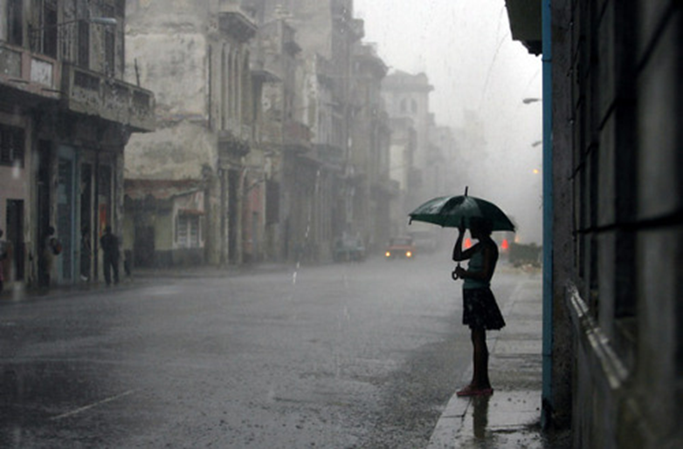

2) Upgrading Sentences – a key way to boost your mark in this exam is by VARYING YOUR SENTENCE STARTS.

Complete the grid below to rewrite the sentence in the middle.

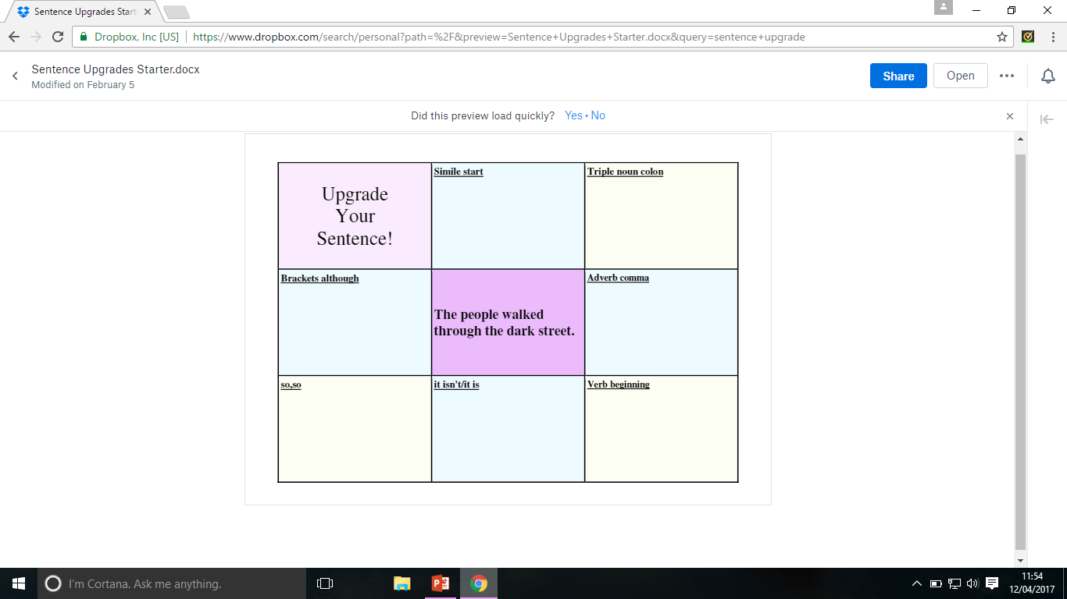

3) Now bullet point as much as you can about the areas within the 3 squares. Consider the weather, feelings, characters and scenery within the image.

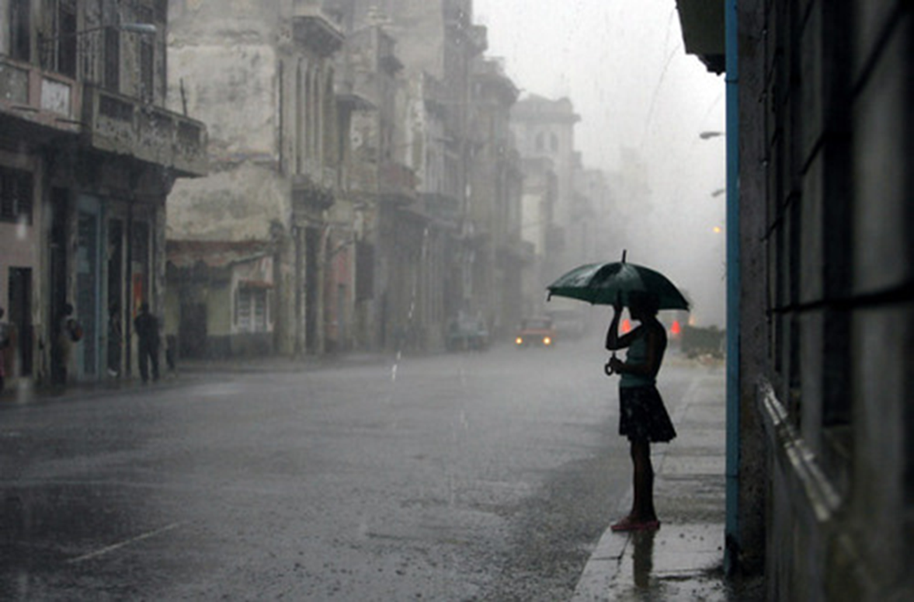

4) Write a description based on the image.

You **should**:

* Include a range of punctuation.
* Include sophisticated vocabulary.
* Include paragraphs.
* Include a variety of sentence openers and sentence structures.
* A variety of techniques.

You **could**:

* Describe what is happening from the perspective of the umbrella.
* Use any type of narrative viewpoint.
* Use flashback to develop the structure of your piece.