Power and Conflict
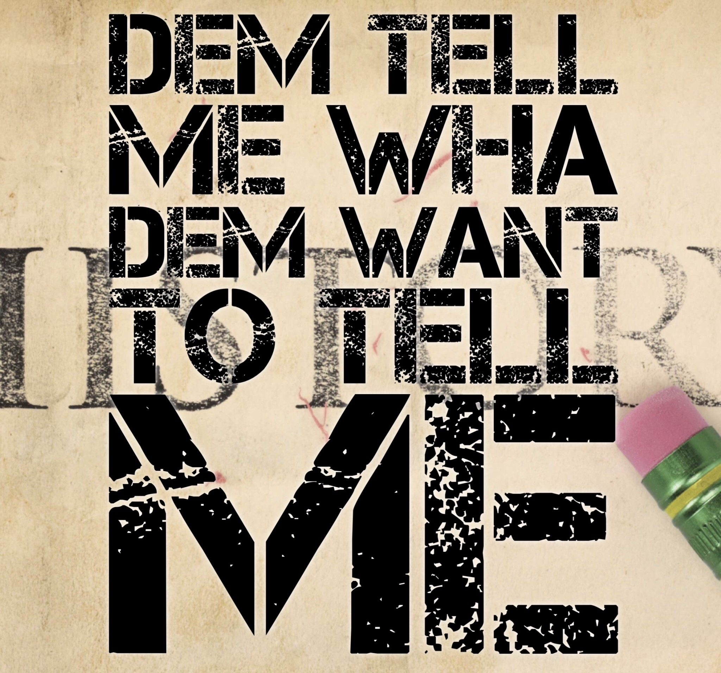
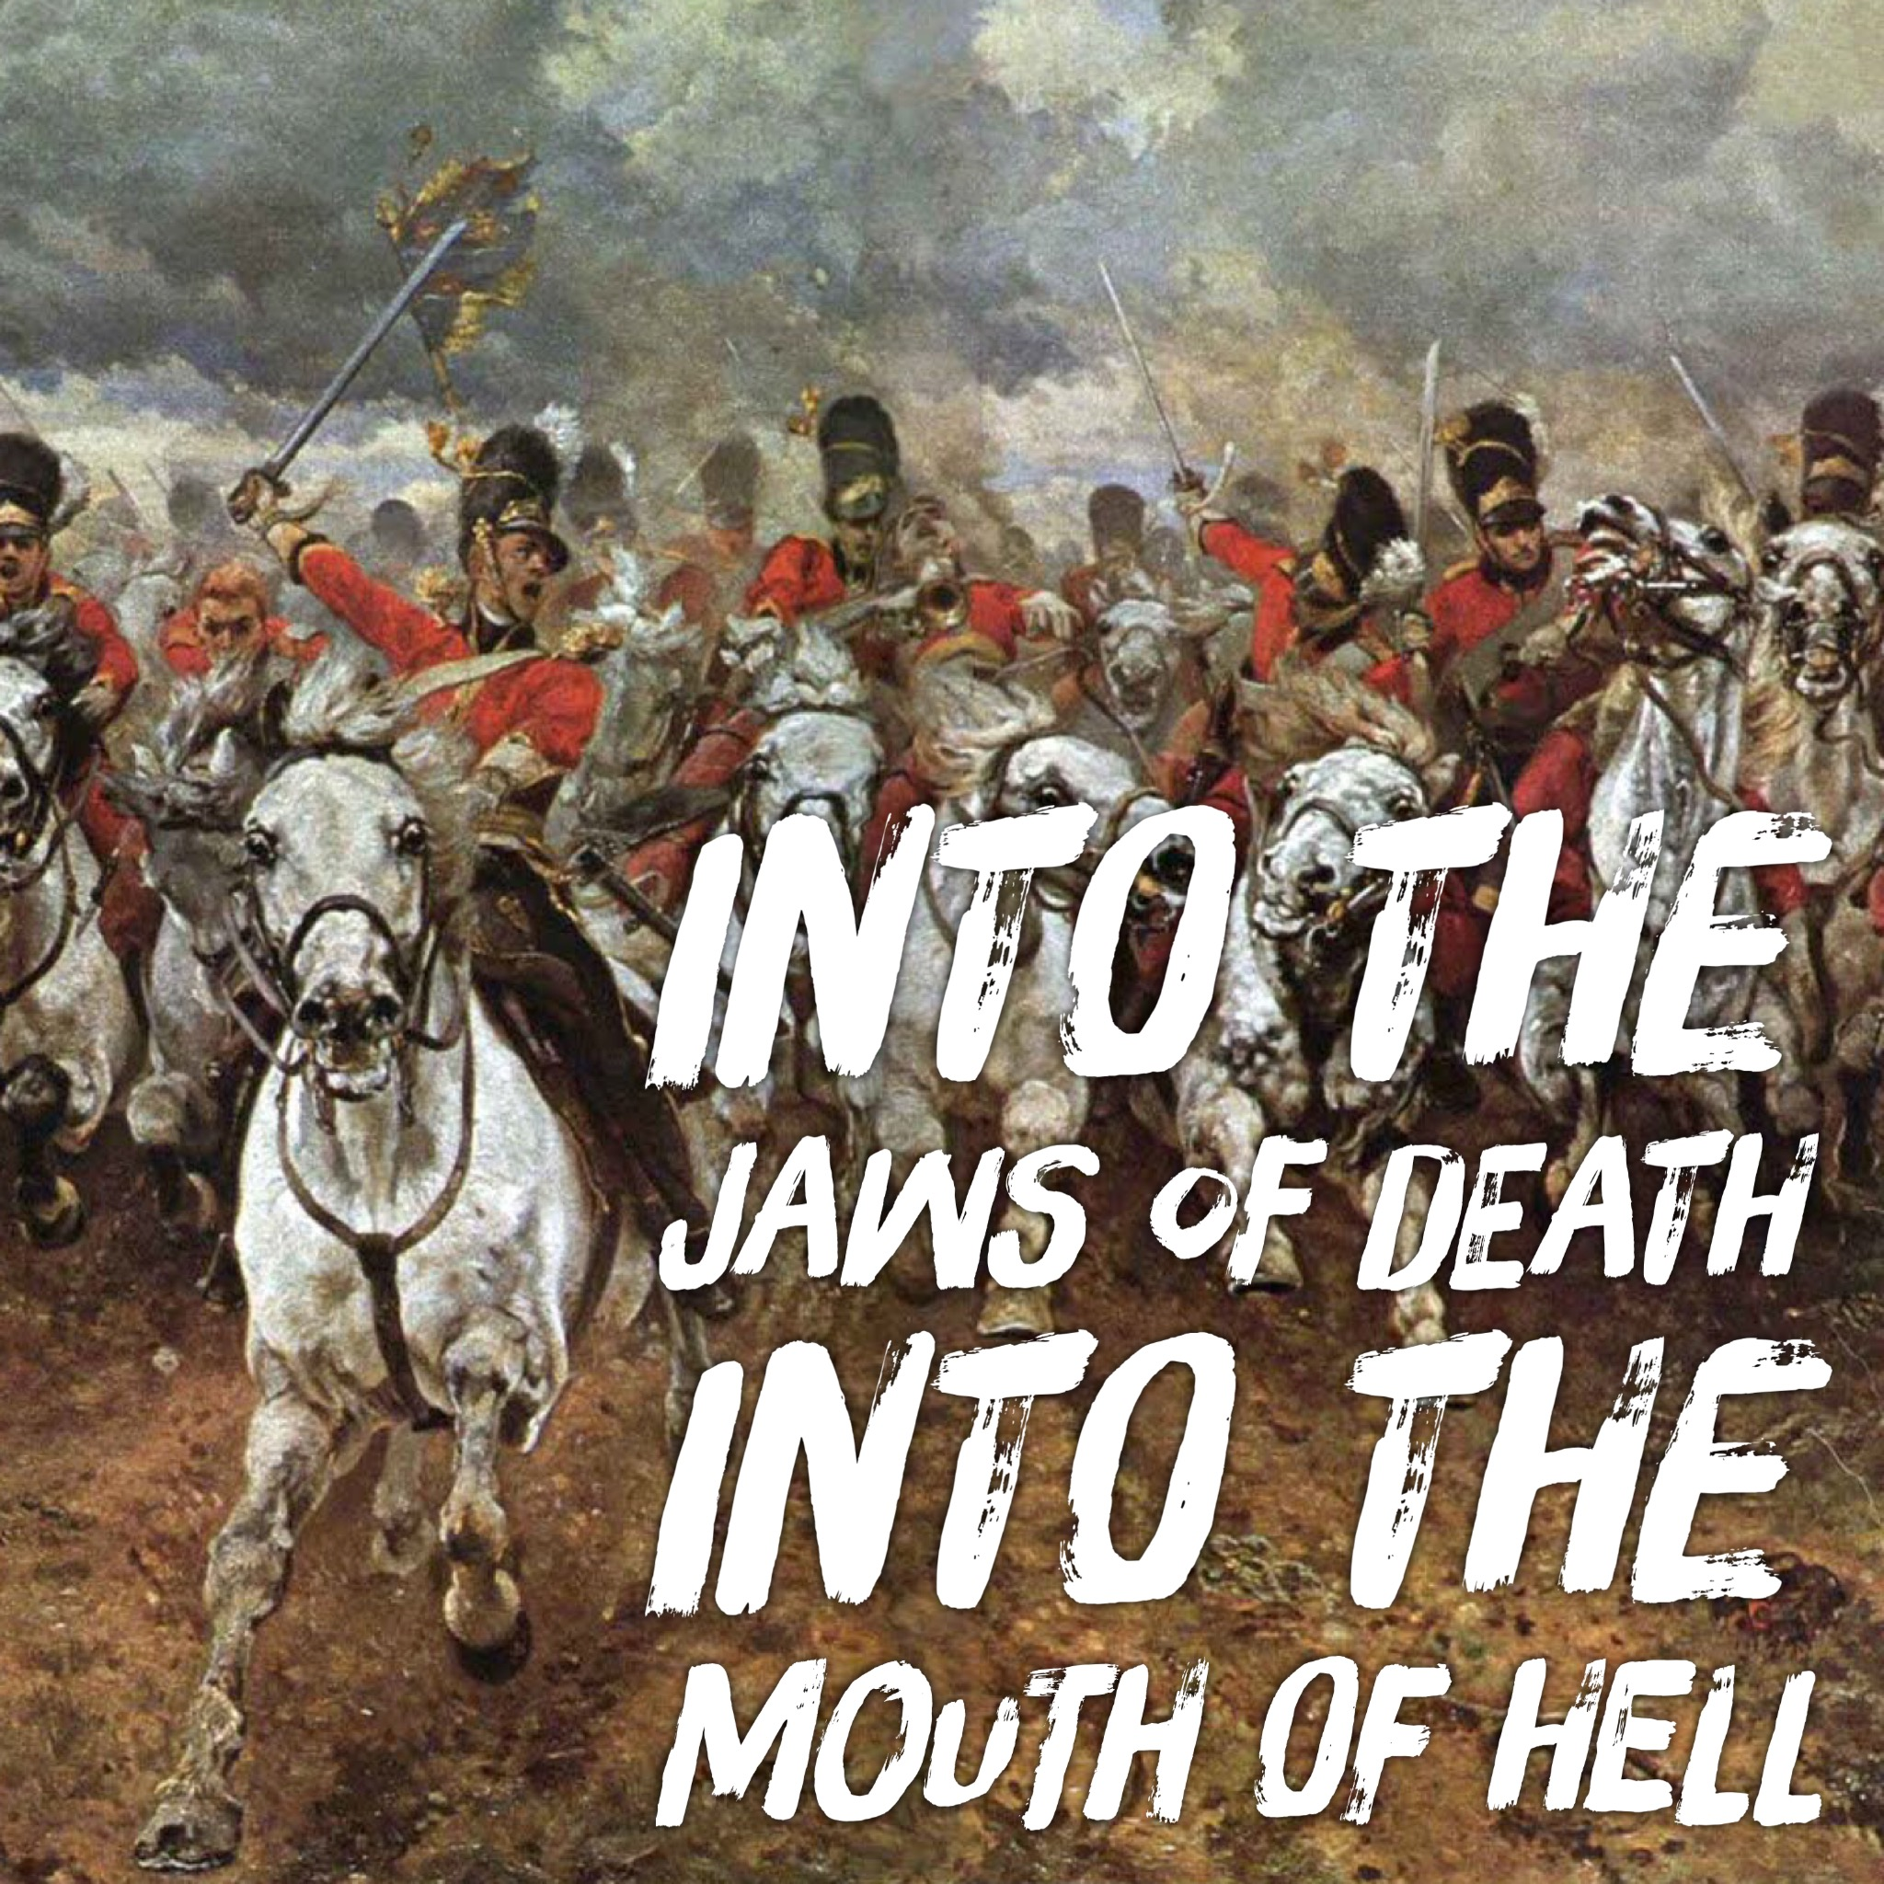
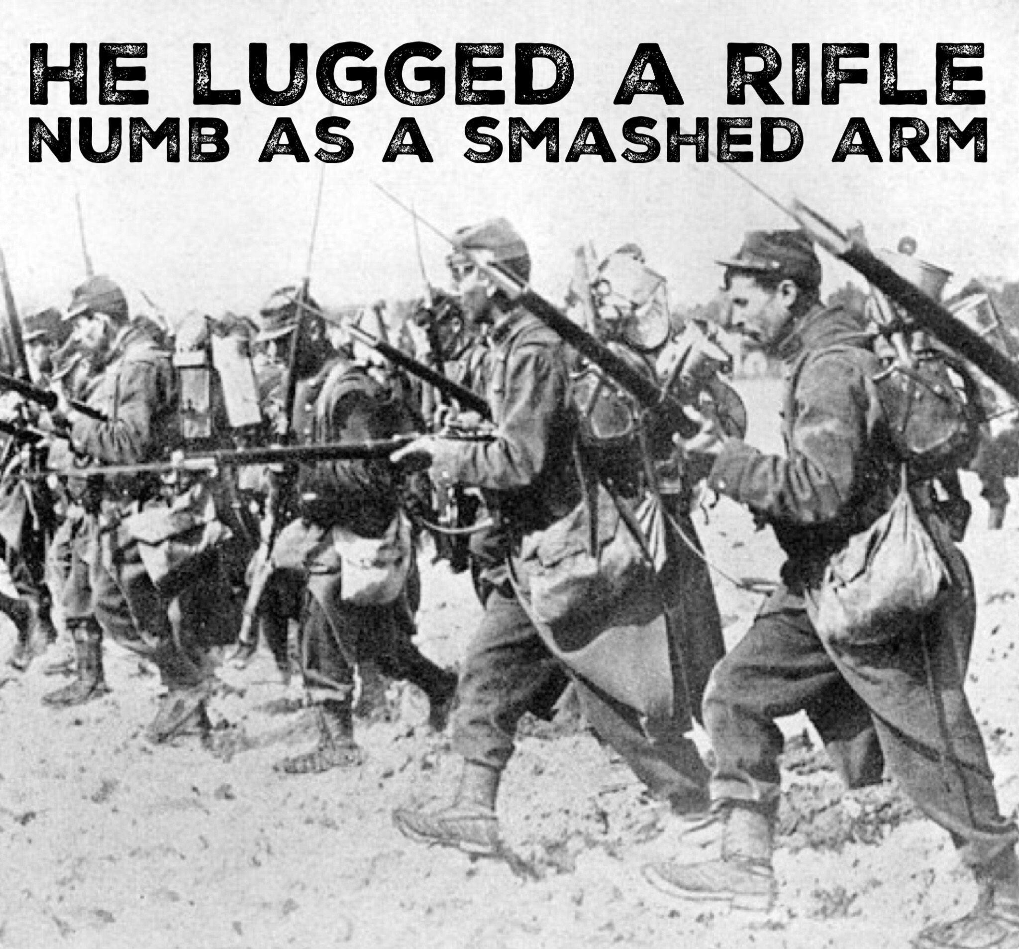

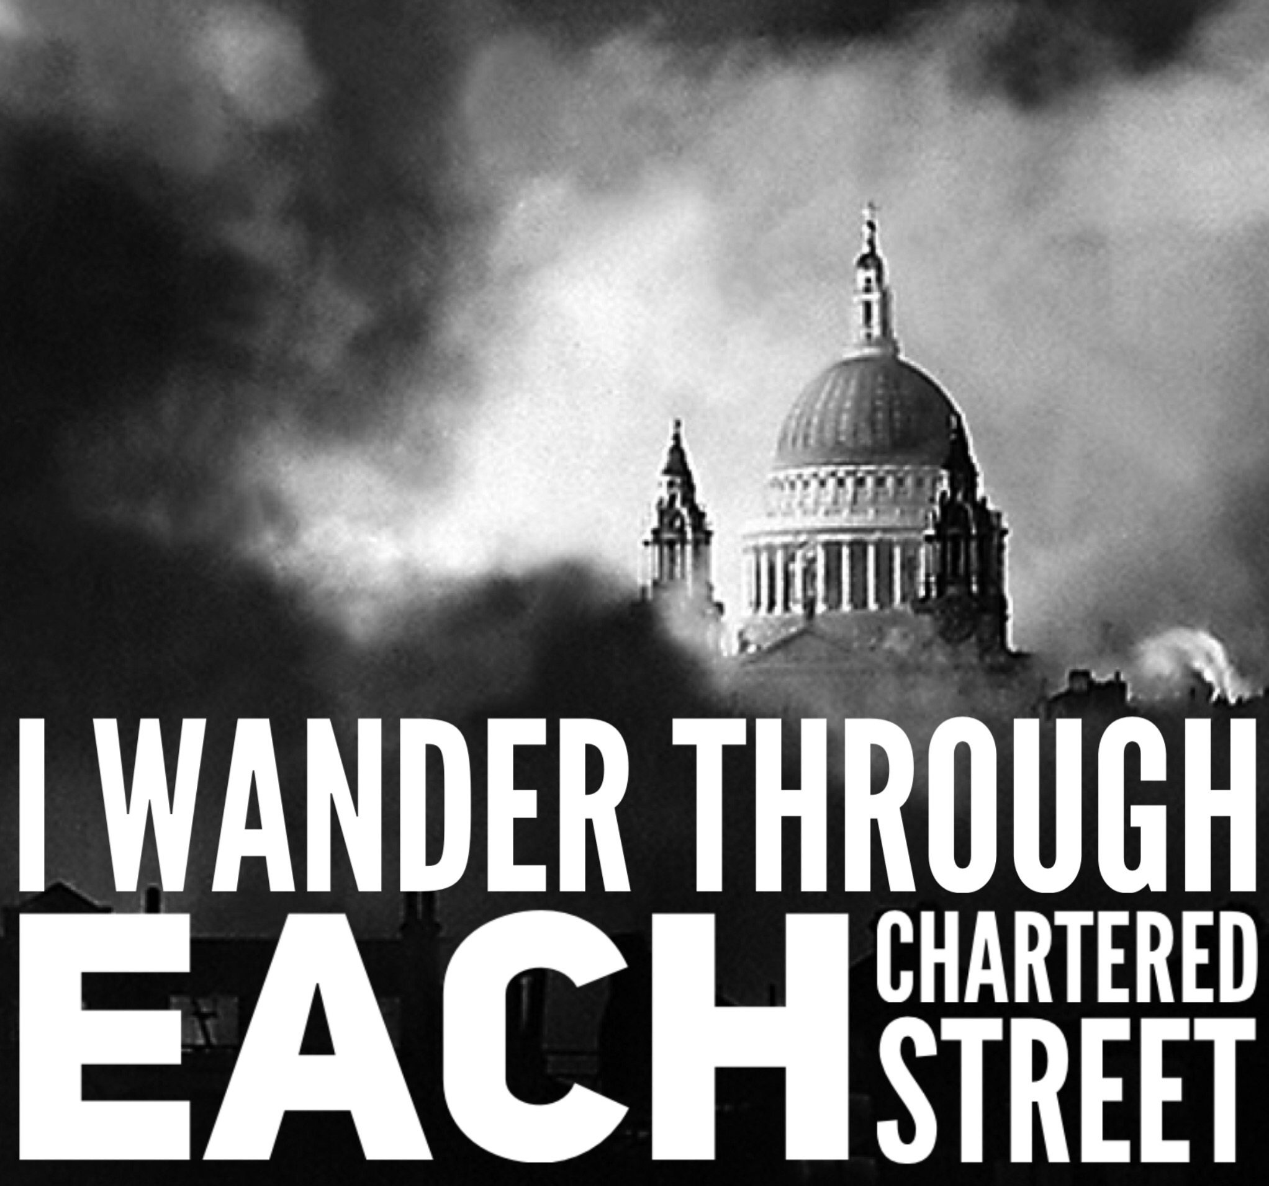
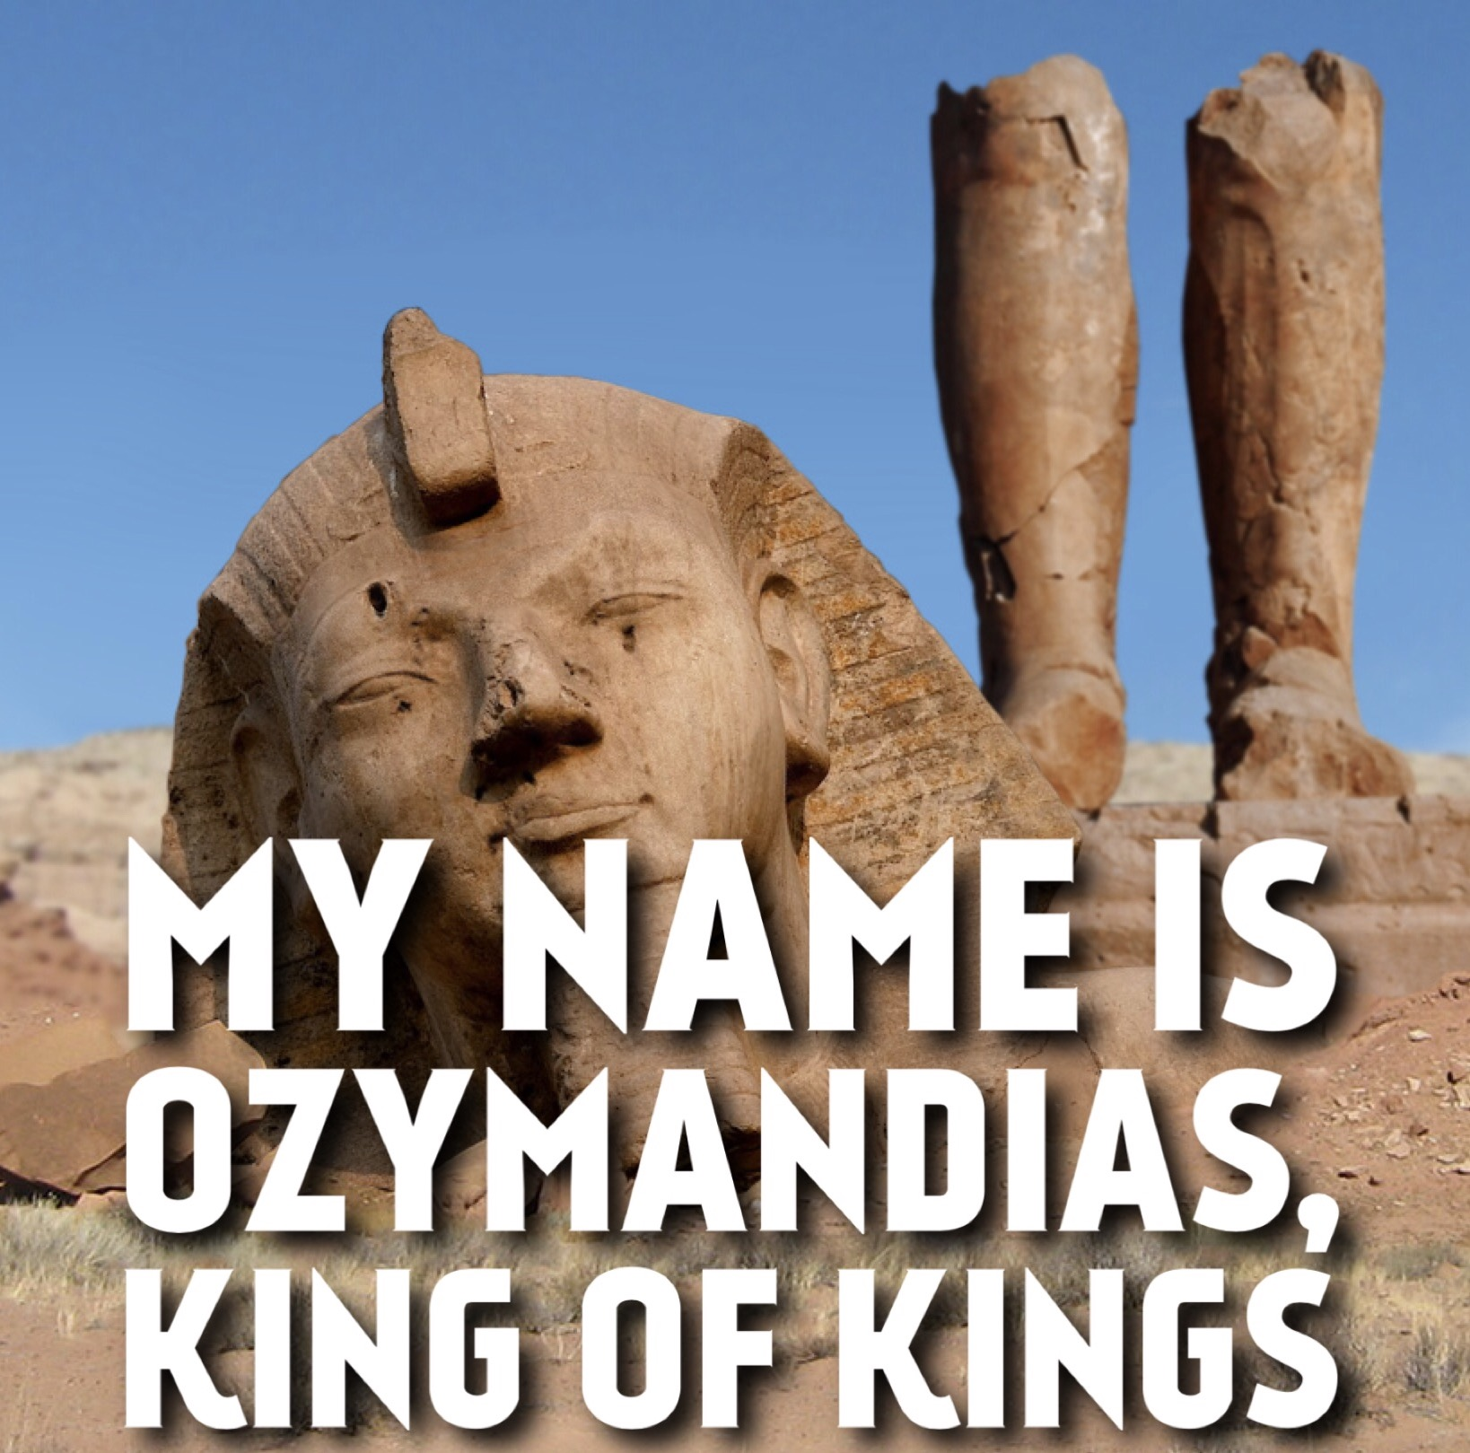
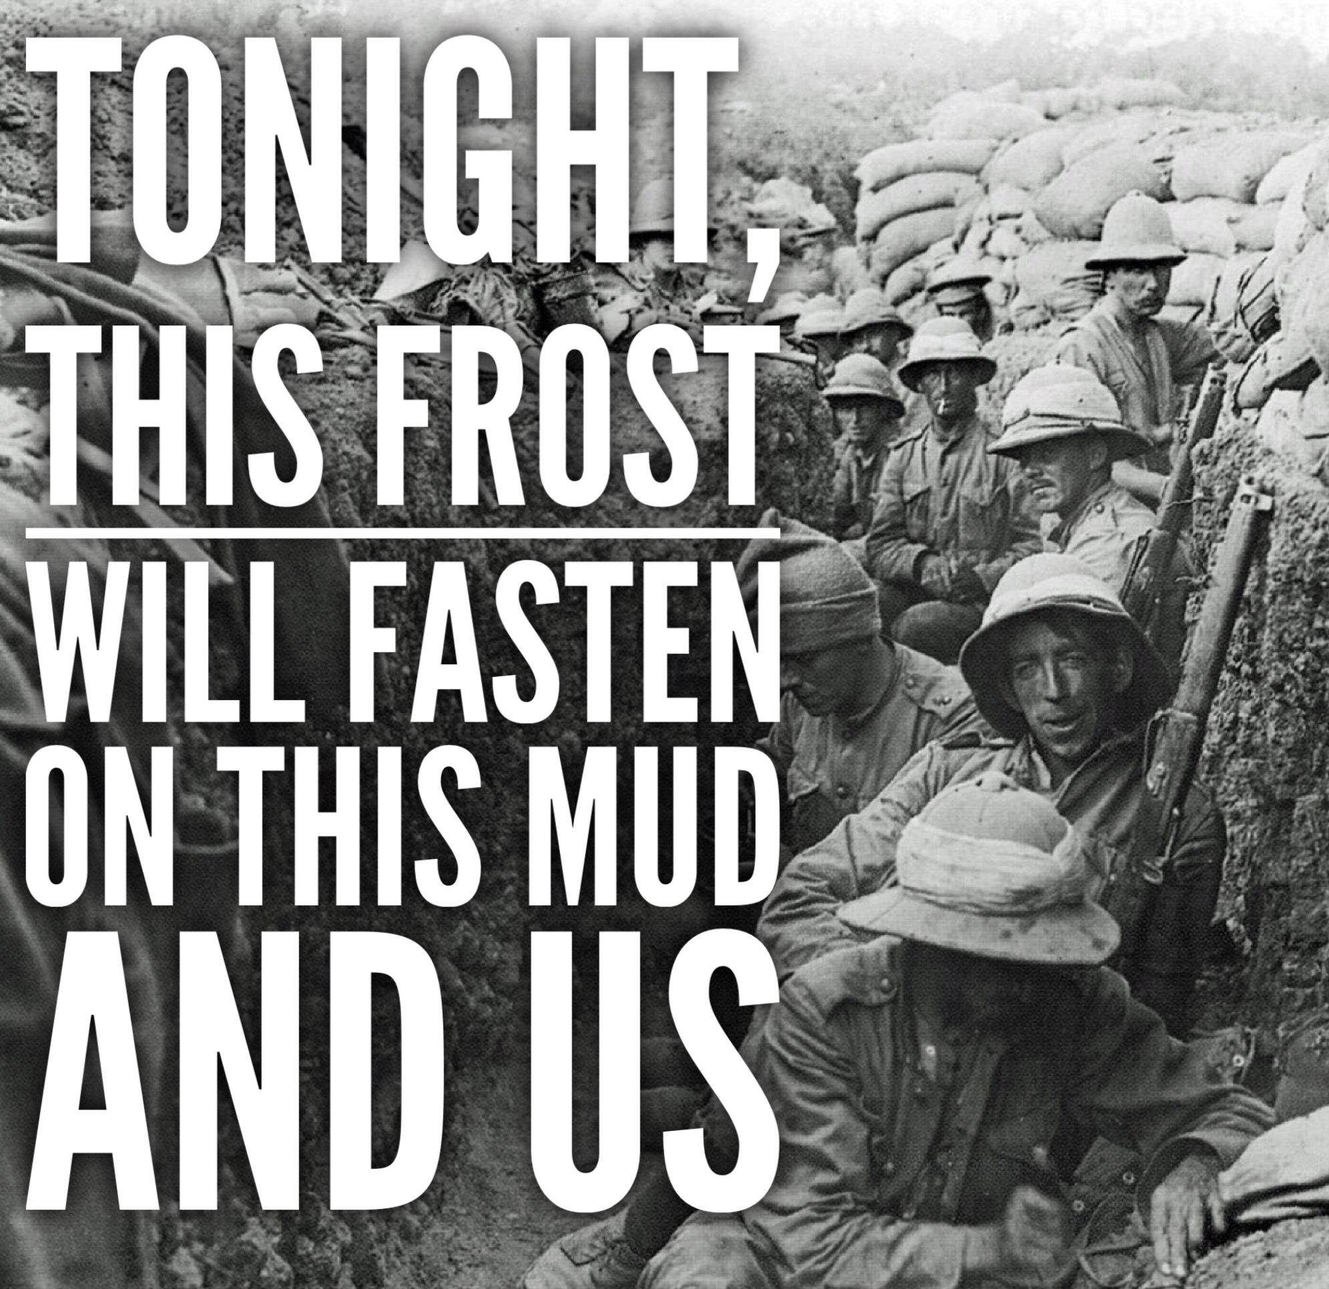

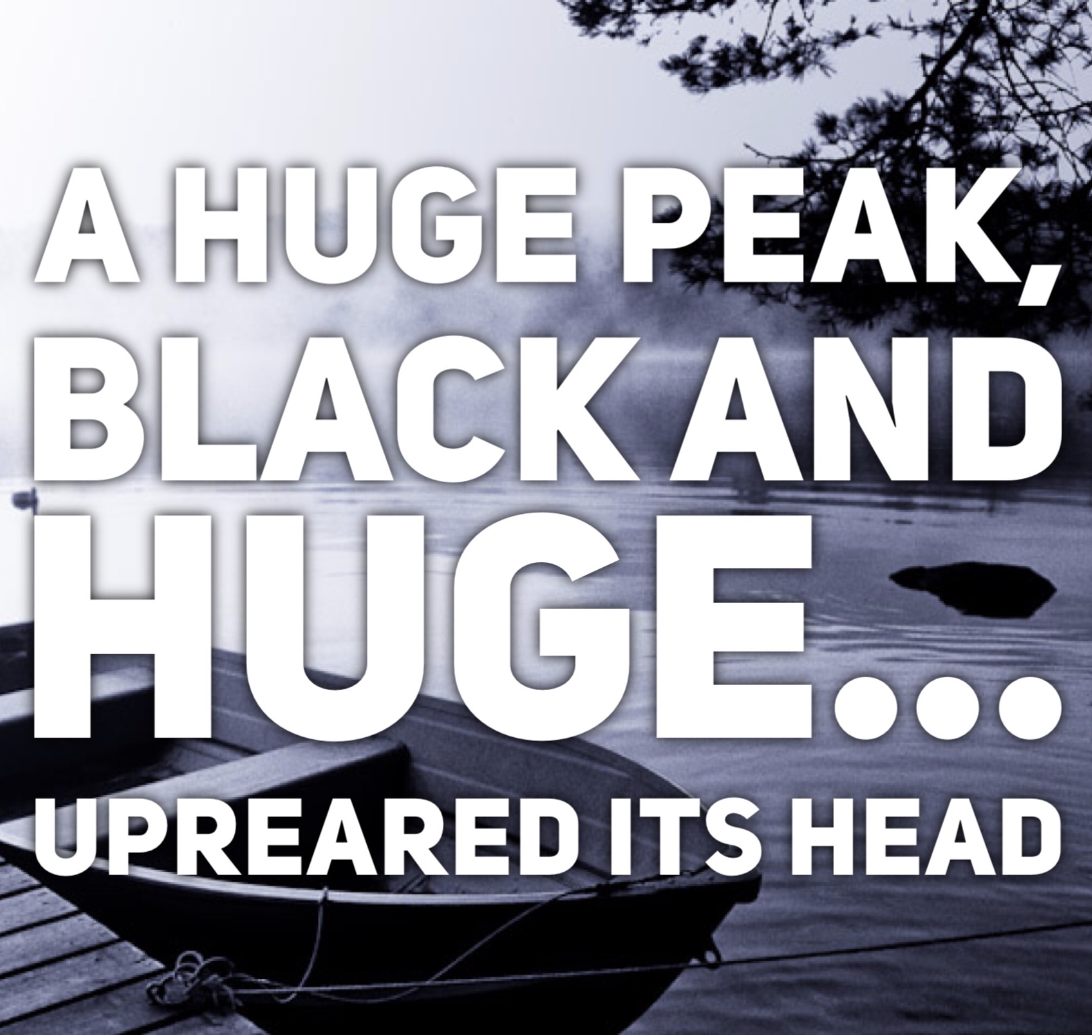
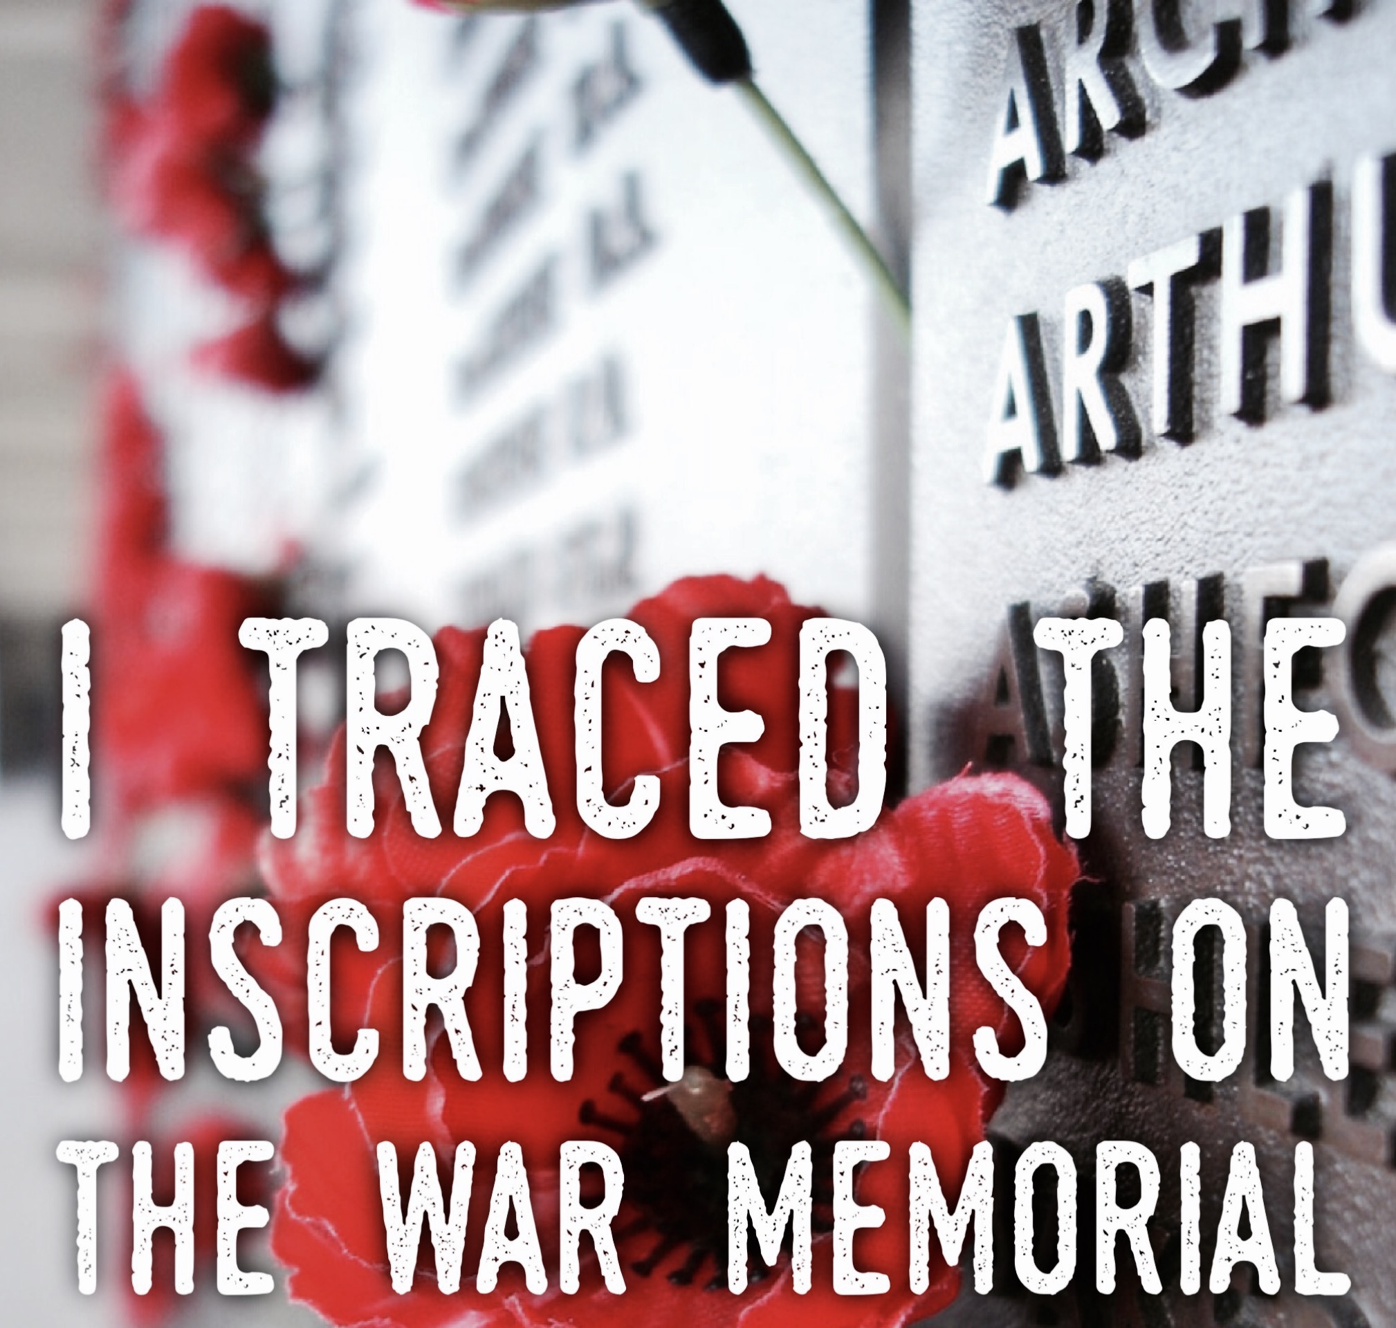
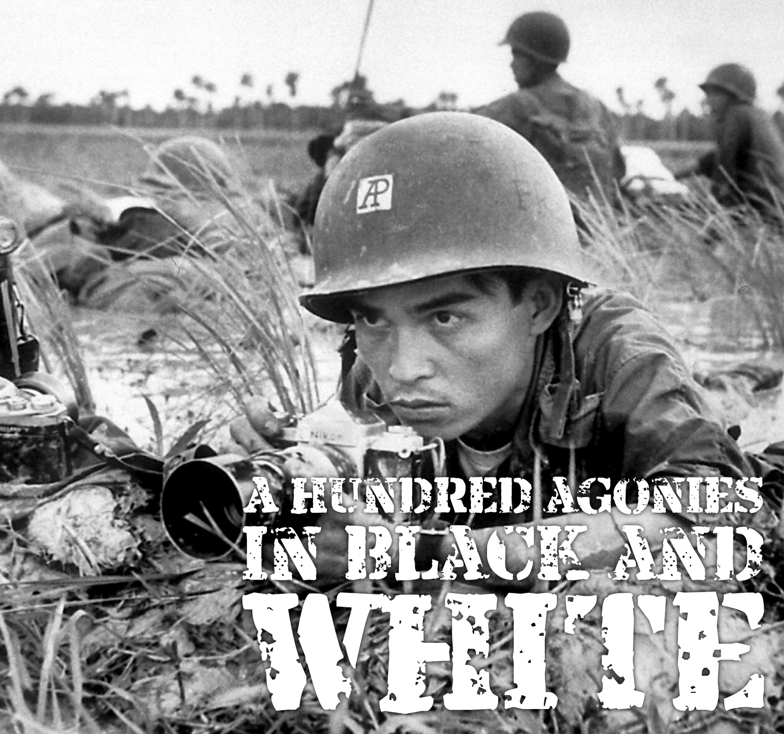

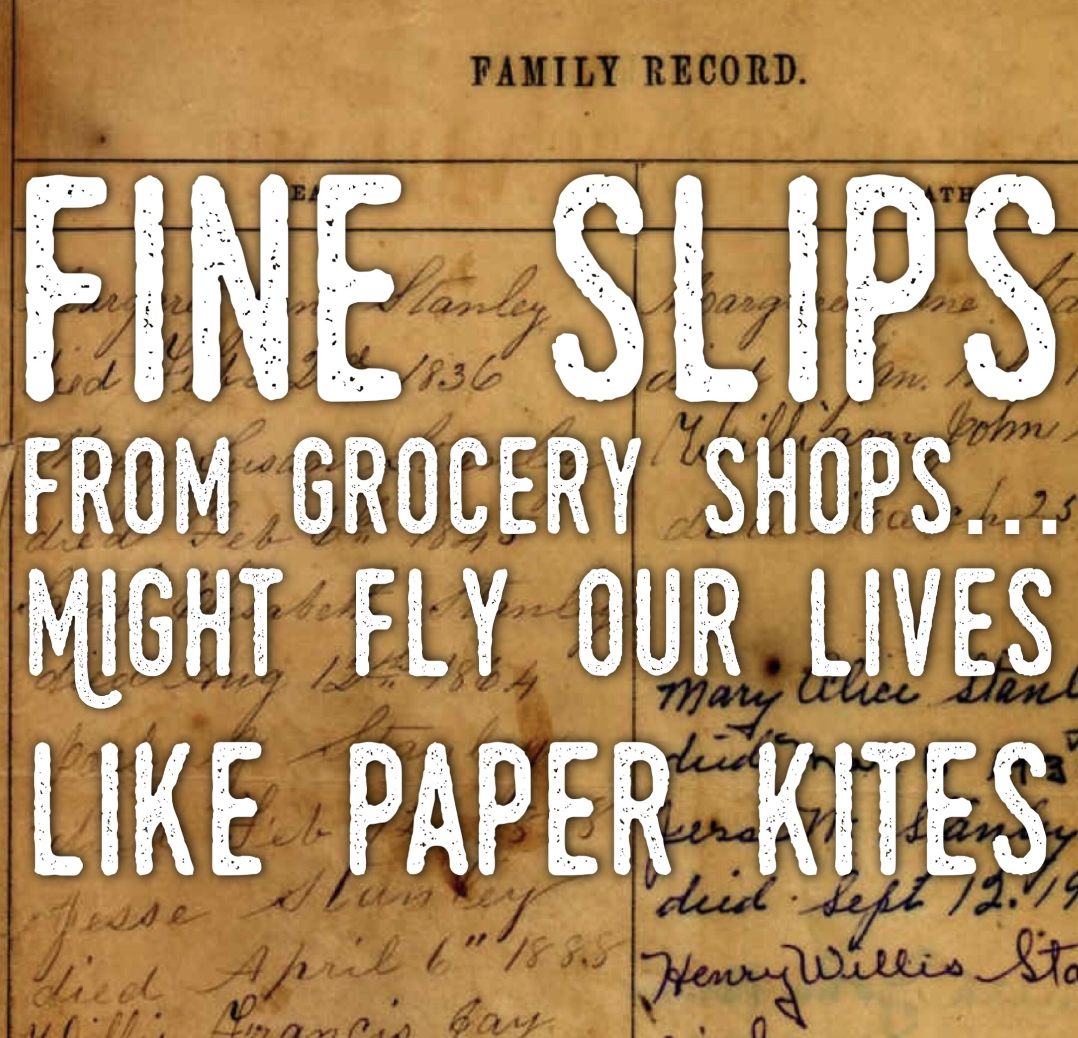
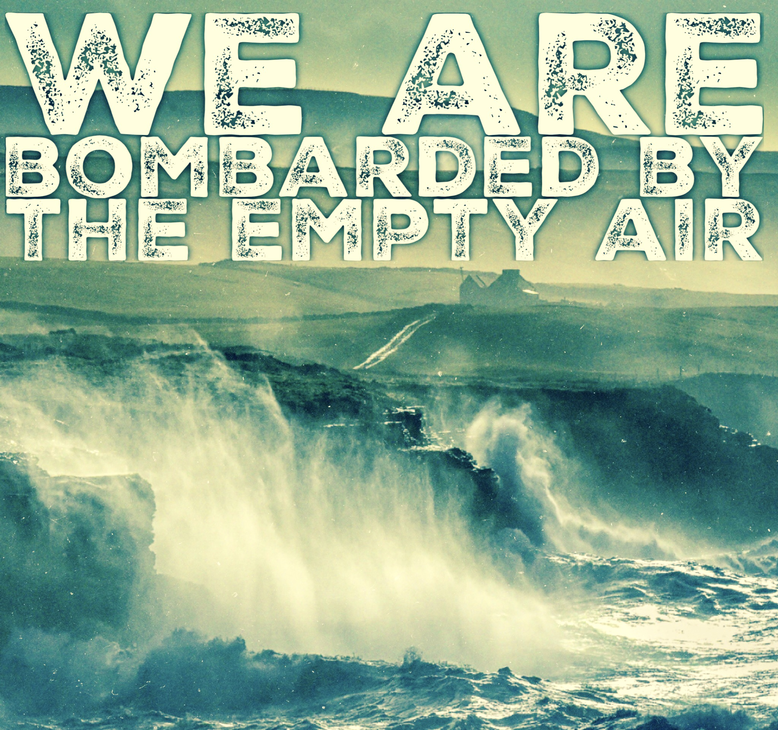
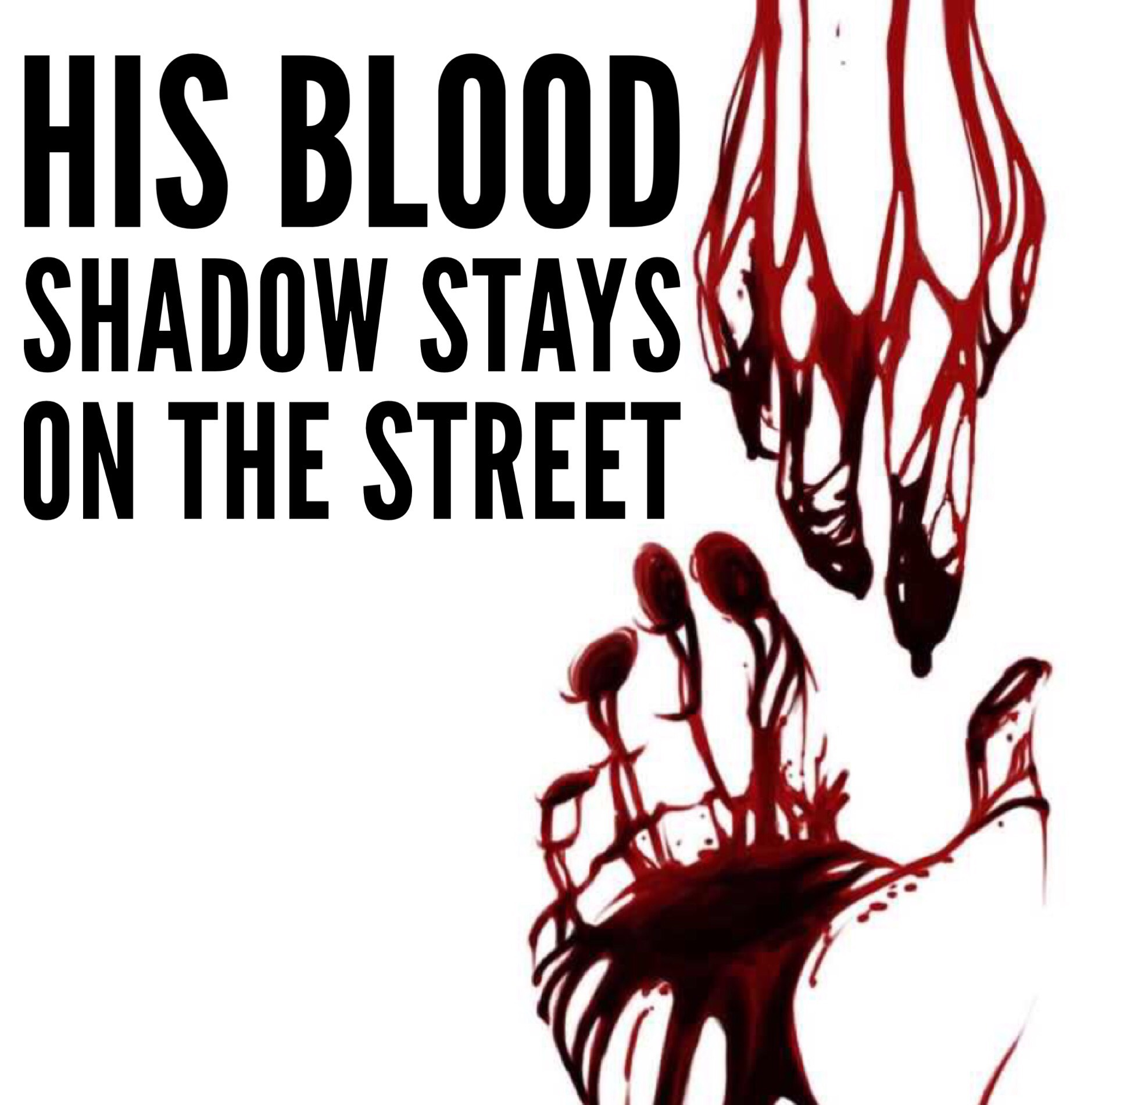

NAME________________________________________________________________________

Literature Paper 2: Modern texts and poetry
This workbook will prepare you for Sections B and C of your literature Paper 2 which deal with poetry. Literature Paper 2 will examine you on:
- Modern prose or drama texts
- The poetry anthology
- Unseen poetry
How it’s assessed
- written exam: 2 hour 15 minutes
- 96 marks
- 60% of your Literature GCSE
Questions
Section A Modern texts: students will answer one essay question from a choice of two on their studied modern prose or drama text.
Section B Poetry: students will answer one comparative question on one named poem printed on the paper and one other poem from their chosen anthology cluster.
You will be assessed on 3 assessment objectives (AOs):
AO1 Read, understand and respond to texts. You should be able to
- Maintain a critical style and develop an informed personal response.
- Use textual references, including quotations, to support and illustrate interpretations. (12 marks)
AO2: Analyse the language, form and structure used by a writer to create meanings and effects, using relevant subject terminology where appropriate. (12 marks)
AO3: Show understanding of the relationships between the texts and the context in which they were written. (6 marks)
Section C Unseen poetry: Students will answer one question on one unseen poem and one question comparing this poem with a second unseen poem.

Contents
ANNOTATED POEMS
Ozymandias
London
The Prelude: Stealing the Boat
My Last Duchess
The Charge of the Light Brigade
Exposure
Storm on the Island
Bayonet Charge
Remains
Poppies
War Photographer
Tissue
The Emigree
Kamikaze
Checking Out Me History
Themes
FLIRT
Exploding a Quotation
How to tackle an unseen poem
Practice Papers
Glossary of Poetic Terms
Mark Scheme

How to use this workbook

Make sure you know
- Who is speaking?
- To whom, if anyone?
- The setting
- What happens – how the situation and ideas are developed
- The viewpoint from which the poem is presented
- The thoughts feelings and attitudes of the people in the poem
- Why you think the poet chose to write the poem (the message).

Ozymandias
I met a traveller from an antique land,
Who said—“Two vast and trunkless legs of stone
Stand in the desert. . . . Near them, on the sand,
Half sunk a shattered visage lies, whose frown,
And wrinkled lip, and sneer of cold command,
Tell that its sculptor well those passions read
Which yet survive, stamped on these lifeless things,
The hand that mocked them, and the heart that fed;
And on the pedestal, these words appear:
My name is Ozymandias, King of Kings;
KEY VOCABULARY
Ozymandias - Ozy comes from the Greek “ozium” which means either, ‘to breathe’ or ‘air’. Mandias comes from the Greek “mandate” which means ‘to rule’.
Antique – old and therefore historic but can also suggest old-fashioned or outdated.
Visage – face.
Mock – this word has a double meaning – it can mean to make a model or but also to make fun of.
Colossal – huge. This word describes the statue but is also a metaphor for the King himself.
Look on my Works, ye Mighty, and despair!
Nothing beside remains. Round the decay
Of that colossal Wreck, boundless and bare
The lone and level sands stretch far away.”
WHAT IS THE POEM ABOUT?
A traveller in the desert comes across the ruined statue of Ozymandias, a former ruler of Ancient Egypt, who was tyrannical and cruel. The arrogant boasts on the inscription are contrasted with the crumbled remains of the statue – all that now remains of his once powerful kingdom.
ABOUT THE AUTHOR
Percy Bysshe Shelley (1792 – 1822) was one of the major English Romantic poets. Shelley was famous for his association with John Keats and Lord Byron. The novelist Mary Shelley (author of Frankenstein) was his wife. He was a political radical whose beliefs in freedom and democracy are often reflected in his poetry.

CONTEXT
This poem is based on a story Shelley had read about a funeral temple of the Egyptian pharaoh, Rameses II, whom the Greeks called Ozymandias. Shelley’s own radical political beliefs led him to reflect on the transient nature of power.
According to the story, the temple bore an inscription which read: ‘I am Ozymandias, king of kings...’
Ramsesses II, during his reign, built more temples and monuments, took more wives (8) and had more children (over 100) than any other pharaoh.
He wanted to build memorials for himself, which he imagined would last forever.
However, he used slave labour to build them and the slaves suffered hardship under his control.
Today, many of these memorials and statues have crumbled into the sands of the desert.

Analytical writing
Answer the questions below using detailed analysis. Make sure you cover all the AOs in your answer.
Choose one of the statements from the box above and use FLIRT to explore it fully.
How does Shelley create a negative picture of a powerful ruler?
How is the power of nature presented in the poem?

Rank the ideas
Below are nine statements about the poem. Rank them in order of how far you agree with them. Share your ideas with a partner. Did they put them in the same order as you? Write a paragraph justifying your choice, using quotations from the poem to support your ideas.
The poem explores power and status.
The poem suggests that we cannot outlive time.
The poem is about legacies and what we leave behind after we die.
The poem suggests that pride comes before a fall.
The poem is about time and nature and how man cannot conquer either.
Shelley suggests that art and language will outlast humans and other legacies of power.
The poet contrasts the inevitable decline of all leaders with their boastful desire to achieve lasting greatness.
Shelley wanted to create a negative image of a powerful ruler.
The poem conveys the idea that everything ends in destruction and decay.
TECHNIQUE WATCH: IRONY
The statue is symbolic of the power of rulers, and therefore the fact that the arrogant boast of its inscription is belied by its ruined sate can be seen as ironic, underlining Shelley’s message that nature is more powerful than man.
QUESTIONS TO ANSWER
- What form has Shelley chosen? Why?
- In your own words, describe what is left of the statue.
- Select evidence that Ozymandias was arrogant?
- Select evidence that Ozymandias could be ruthlessly domineering.
- Select evidence that the sculptor was good at his job.
- We know that Ozymandias was a proud and vain king because the inscription reads ‘…
- However, he was powerful for only a relatively short time as is evident…
- Select evidence that reinforces the idea that human life and power is transient but that time is eternal.
GET YOUR FLIRT ON
Form – The poem is a sonnet. Find the definition of a sonnet in the glossary at the back of this booklet. Does the rhyme scheme differ in any way? How?
Language – What language techniques are being used and what are their effects. Can you find examples of alliteration, metaphor and irony?
Imagery – Some strong images are evoked in this poem. Pick two of the most vivid pictures and examine the language used to create them.
Rhyme/Rhythm – Note the rhyme scheme and the metre (iambic pentameter).
Tone/Theme - What it the overall feeling of the poem? What emotions are being conveyed? What is the overall message of the poem?

London
KEY VOCABULARY
Charter’d – owned, or legally regulated.
Woe – sadness
Ban – to forbid something
Mind-forged – created by thought
Manacles – handcuffs
Harlot – prostitute
Blights with plagues the Marriage hearse – venereal diseases carried by prostitutes are passed on to married women and kill them.

I wander thro' each charter'd street,
Near where the charter'd Thames does flow.
And mark in every face I meet
Marks of weakness, marks of woe.

In every cry of every Man,
In every Infants cry of fear,
In every voice: in every ban,
The mind-forg'd manacles I hear

How the Chimney-sweepers cry
Every blackning Church appalls,
CONTEXT
William Blake was alive and working during the age of The Enlightenment. The Enlightenment took place between 1700 and 1900 and was a period of massive social, economic, political and scientific upheaval. The Enclosure laws and the Industrial Revolution had brought huge numbers of peasants out of the countryside and into cities such as London looking for work. The poem London is taken from Songs of Experience a collection of poems that illustrate the effects of modern life on people and nature. Appalling industrial conditions, child labour, prostitution and poverty are just some of the topics Blake explores.

And the hapless Soldiers sigh
Runs in blood down Palace walls

But most thro' midnight streets I hear
How the youthful Harlots curse
Blasts the new-born Infants tear
And blights with plagues the Marriage hearse

ABOUT THE AUTHOR
William Blake was a poet and artist who specialised in religious imagery but who rejected established religion for a number of reasons. One of the main reasons Blake rejected the Church of England was its failure to help children in London who were forced to work.

WHAT IS THE POEM ABOUT?
The poem describes a journey through London, providing an insight into the terrible conditions faced by the city’s poor. Poverty, child labour and prostitution are all described by the poet. ‘London’ begins with an attack on the new capitalism of the 1700s in the lines, ‘I wander through each chartered street / Near where the chartered Thames does flow’, a bitter reference to the way in which every aspect of life in London is owned, even the river. The river is often a symbol of freedom and nature but here it is presented as being owned by businessmen who profit from it. Blake's poem also criticises the Church and its failure to protect the most vulnerable. The poet describes the cry of the chimney sweeper and the blackening of church walls, suggesting that the church as an institution is neglecting those who need it the most. The poem ends with a hellish vision of child prostitution and the horrific consequences of sexually transmitted diseases.

QUESTIONS TO ANSWER
- How can a river be ‘chartered?
- What is the effect of the phrase ‘every infant’s cry of fear?
- What do you think a ‘mindforged manacle’ might be?
- Why might Blake have used the adjective ‘black’ning’ to describe the churches? Why might the chimney sweepers cry appall them?
- What is the relationship between the soldier and the palace?
- What does the image ‘midnight streets’ suggest to you?
- Why might Blake suggest that the harlot is ‘youthful’?
- What is the effect of the infant being described as ‘newborn’?

FOCUS ON IMAGERY
The poem uses vivid images to depict London as a city characterized by lack of freedom, sorrow, pain and suffering. Highlight all the images that strike you as creating this impression.

ANALYSE THE POEM
Answer the questions below using detailed analysis. Make sure you cover all the AOs in your answer.
How does the poet convey a sense of hopelessness?
What is the overall picture of London presented in the poem?
‘Man is born free, yet everywhere he is in chains’ (Rousseau). How far do you agree that this is the view presented by Blake in London?

GET YOUR FLIRT ON
Form – The poem is a ballad. Find out what the conventions of this form are. Why might Blake have chosen it for this subject?
Language – What language techniques are being used and what are their effects. Can you find examples of repetition, alliteration, emotive language and sensory description?
Imagery – Some strong images of misery and deprivation are evoked in this poem. Pick two of the most vivid pictures and examine the language used to create them.
Rhyme/Rhythm – Note the rhyme scheme and the metre (iambic pentameter). How do they affect the reader?
Tone/Theme - What it the overall feeling of the poem? What emotions are being conveyed? What is the overall message of the poem?

Make sure you know
- Who is speaking?
- To whom, if anyone?
- The setting
- What happens – how the situation and ideas are developed
- The viewpoint from which the poem is presented
- The thoughts feelings and attitudes of the people in the poem
- Why you think the poet chose to write the poem (the message).

WRITE YOUR OWN POEM
Write a poem about a modern-day town or city you know well, in the style of London. Make sure you use quatrains (four-line verses) and iambic pentameter and incorporate some of Blake’s key techniques such as repetition, alliteration and emotive language.

As if with voluntary power instinct,
Upreared its head. I struck and struck again,
And growing still in stature the grim shape
Towered up between me and the stars, and still,
For so it seemed, with purpose of its own
And measured motion like a living thing,
Strode after me. With trembling oars I turned,
And through the silent water stole my way
Back to the covert of the willow tree;
There in her mooring-place I left my bark, -
And through the meadows homeward went, in grave
And serious mood; but after I had seen
That spectacle, for many days, my brain
Worked with a dim and undetermined sense
Of unknown modes of being; o'er my thoughts
There hung a darkness, call it solitude
Or blank desertion. No familiar shapes
Remained, no pleasant images of trees,
Of sea or sky, no colours of green fields;
But huge and mighty forms, that do not live
Like living men, moved slowly through the mind
By day, and were a trouble to my dreams.

The Prelude: Stealing the Boat
One summer evening (led by her) I found
A little boat tied to a willow tree
Within a rocky cove, its usual home.
Straight I unloosed her chain, and stepping in
Pushed from the shore. It was an act of stealth
And troubled pleasure, nor without the voice
Of mountain-echoes did my boat move on;
Leaving behind her still, on either side,
Small circles glittering idly in the moon,
Until they melted all into one track
Of sparkling light. But now, like one who rows,
Proud of his skill, to reach a chosen point
With an unswerving line, I fixed my view
Upon the summit of a craggy ridge,
The horizon's utmost boundary; far above
Was nothing but the stars and the grey sky.
She was an elfin pinnace; lustily
I dipped my oars into the silent lake,
And, as I rose upon the stroke, my boat
Went heaving through the water like a swan;
When, from behind that craggy steep till then
The horizon's bound, a huge peak, black and huge,
ABOUT THE AUTHOR
William Wordsworth William Wordsworth was an early leader of romanticism (a literary movement that celebrated nature and concentrated on human emotions) in English poetry and ranks as one of the greatest lyric poets in the history of English literature. Wordsworth shared the general romantic notion that personal experience is the only way to gain living knowledge. The purpose of The Prelude was to recapture and interpret, with detailed thoroughness, the whole range of experiences that had contributed to the shaping of his own mind. Wordsworth was Britain's Poet Laureate from 1843 until his death in 1850
Read more: http://www.notablebiographies.com/We-Z/Wordsworth-William.html#ixzz4IBODFBI7

MOODS AND FEELINGS
Analyse the moods and feelings of the writer and how they change as the poem progresses. Use the sentence starters below to help:
At the beginning of the poem, the boy feels...
As he beings to row, he...
As he rows further, he notices...
He returns home feeling...
For some time after that, he ...
To conclude, the reader can see that his feelings change from...

KEY VOCABULARY
Elfin Pinnace – fairy boat
Lustily – with energy and enjoyment
Covert – hiding place

CONTEXT
As a Romantic poet, Wordsworth was interested in the way in which Nature both reflects and shapes human emotions and how humans can learn from Nature.

GET YOUR FLIRT ON
Form/Structure – This is an extract from a much longer poem. The poet makes a lot of use of enjambement. What effect does this have?
Language – What language techniques are being used and what are their effects. Can you find examples of metaphor, personification and juxtaposition?
Imagery – The poet creates some very vivid pictures of the mountain. Pick out at least two phrases describing the mountain and examine the connotations of the language and its impact.
Rhyme/Rhythm – This poem uses blank verse (unrhymed) and the metre is iambic pentameter. Look up blank verse in the glossary. What is its effect here?.
Tone/Theme - What it the overall feeling of the poem? Is there a contrast between different parts of the poem? What emotions does the boy feel? What is the overall message of the poem?
WHAT IS THE POEM ABOUT?
This is a piece of poetry about Wordsworth’s childhood and how it helped shape the adult he became. In the extract the young Wordsworth takes a boat, without permission, for a row on Ullswater at night. His feelings of guilt summon up a vision of the mountain opposite looming out of the darkness as if to punish him. Although Wordsworth quickly returns the boat, he is haunted for many nights by the memory.

QUESTIONS TO ANSWER

- The poem is very deliberately structured to reflect the boy’s journey from innocence to awareness. Looking at the two lines beginning “When from behind that craggy steep…” explain why they mark a turning point in the poem. How does the mood change here?
- The poet uses personification to draw a portrait of the mountain as vengeful and angry. Find two phrases that personify the mountain and explain their effect.
- How is nature depicted in this poem? Find two contrasting descriptions of nature and explore their connotations.
- Why has this poem been included in the Power and Conflict anthology? Write two paragraphs explaining where you think these two themes are evident in the poem?

Would draw from her alike the approving speech,
Or blush, at least. She thanked men—good! but thanked
Somehow—I know not how—as if she ranked
My gift of a nine-hundred-years-old name
With anybody’s gift. Who’d stoop to blame
This sort of trifling? Even had you skill
In speech—which I have not—to make your will
Quite clear to such an one, and say, “Just this
Or that in you disgusts me; here you miss,
Or there exceed the mark”—and if she let
Herself be lessoned so, nor plainly set
Her wits to yours, forsooth, and made excuse—
E’en then would be some stooping; and I choose
Never to stoop. Oh, sir, she smiled, no doubt,
Whene’er I passed her; but who passed without
Much the same smile? This grew; I gave commands;
Then all smiles stopped together. There she stands
As if alive. Will’t please you rise? We’ll meet
The company below, then. I repeat,
The Count your master’s known munificence
Is ample warrant that no just pretense
Of mine for dowry will be disallowed;
Though his fair daughter’s self, as I avowed
At starting, is my object. Nay, we’ll go
Together down, sir. Notice Neptune, though,
Taming a sea-horse, thought a rarity,
Which Claus of Innsbruck cast in bronze for me!
Robert Browning

My Last Duchess
That’s my last Duchess painted on the wall,
Looking as if she were alive. I call
That piece a wonder, now; Fra Pandolf’s hands
Worked busily a day, and there she stands.
Will’t please you sit and look at her? I said
“Fra Pandolf” by design, for never read
Strangers like you that pictured countenance,
The depth and passion of its earnest glance,
But to myself they turned (since none puts by
The curtain I have drawn for you, but I)
And seemed as they would ask me, if they durst,
How such a glance came there; so, not the first
Are you to turn and ask thus. Sir, ’twas not
Her husband’s presence only, called that spot
Of joy into the Duchess’ cheek; perhaps
Fra Pandolf chanced to say, “Her mantle laps
Over my lady’s wrist too much,” or “Paint
Must never hope to reproduce the faint
Half-flush that dies along her throat.” Such stuff
Was courtesy, she thought, and cause enough
For calling up that spot of joy. She had
A heart—how shall I say?— too soon made glad,
Too easily impressed; she liked whate’er
She looked on, and her looks went everywhere.
Sir, ’twas all one! My favour at her breast,
The dropping of the daylight in the West,
The bough of cherries some officious fool
Broke in the orchard for her, the white mule
She rode with round the terrace—all and each

ABOUT THE AUTHOR
Robert Browning (1812-1889) was a popular Victorian poet. He is best known for his dramatic monologues, written in character. He was a frequent visitor to Italy and this poem, like many of his works, is set there. He married the poet Elizabeth Barrett against the wishes of her father and this lack of regard for convention is an attitude also expressed in many of his poems.

GET CREATIVE

Imagine you are the visitor from the poem (the Count’s envoy). Following your meeting with the Duke, what will you tell the Count? Write the report you will send to him.

WHAT IS THE POEM ABOUT?
The speaker (the Duke of Ferrara) talks to the representative of a Count whose daughter he wishes to marry. He shows this man a portrait of his previous wife. The portrait is usually kept behind a curtain. He describes what his “last duchess” was like. It is implied that the Duke murdered his wife for her flirtatious and outgoing nature. The Duke is depicted as jealous, controlling and aggressive.

QUESTIONS TO ANSWER
- Does the Duke ever refer to his ‘last Duchess’ by name? What does this suggest?
- What do you think happened to the Duke’s last wife? Give evidence in your answer.
- What do you imagine the relationship was like between the Duke and the Duchess?
- Why was the Duke so upset that the Duchess did not ‘respect’ his ‘gift’ of a 900 years old name?
- Read the final lines of the poem again. Why does Browning describe the image of Neptune and the sea-horse? What could it represent?
- What impression do we get of the character of the Duke?
- Themes: What are the key themes here?
- How can this poem be linked to other poems you have looked at so far?
CONTEXT
The Duke of Ferrara was a real person. He was Duke of Ferrara (in Italy) from 1559 to 1597. He was married three times and his first wife’s death was treated as suspicious – poisoning

KEY VOCABULARY
Countenance – face
Stoop – bend
Munificence – generosity
Just pretence – fair request

GET YOUR FLIRT ON
Form/Structure – My Last Duchess is a dramatic monologue. Look up the definition in the glossary. What features can you find in the poem that match the description of a dramatic monologue.
Language – What language techniques are being used and what are their effects. Can you find examples of dramatic irony. Look at the use of pronouns – especially I and my. What do they suggest?
Imagery – What kind of imagery does the poet use to depict the Duchess. What kind of picture is painted of her?
Rhyme/Rhythm – This poem uses rhyming couplets (look it up in the glossary) and the metre is iambic pentameter. Why do you think the poet chose this pattern?
Tone/Theme - What it the overall feeling of the poem? What emotions can you identify? How is the theme of Power developed?
Make sure you know
- Who is speaking?
- To whom, if anyone?
- The setting
- What happens – how the situation and ideas are developed
- The viewpoint from which the poem is presented
- The thoughts feelings and attitudes of the people in the poem
- Why you think the poet chose to write the poem (the message).

IV
Flashed all their sabres bare,
Flashed as they turned in air
Sabring the gunners there,
Charging an army, while
All the world wondered.
Plunged in the battery-smoke
Right through the line they broke;
Cossack and Russian
Reeled from the sabre stroke
Shattered and sundered.
Then they rode back, but not
Not the six hundred.

V
Cannon to right of them,
Cannon to left of them,
Cannon behind them
Volleyed and thundered;
Stormed at with shot and shell,
While horse and hero fell.
They that had fought so well
Came through the jaws of Death,
Back from the mouth of hell,
All that was left of them,
Left of six hundred.

VI
When can their glory fade?
O the wild charge they made!
All the world wondered.
Honour the charge they made!
Honour the Light Brigade,
Noble six hundred!

The Charge of the Light Brigade
I
Half a league, half a league,
Half a league onward,
All in the valley of Death
Rode the six hundred.
“Forward, the Light Brigade!
Charge for the guns!” he said.
Into the valley of Death
Rode the six hundred.

II
“Forward, the Light Brigade!”
Was there a man dismayed?
Not though the soldier knew
Someone had blundered.
Theirs not to make reply,
Theirs not to reason why,
Theirs but to do and die.
Into the valley of Death
Rode the six hundred.

III
Cannon to right of them,
Cannon to left of them,
Cannon in front of them
Volleyed and thundered;
Stormed at with shot and shell,
Boldly they rode and well,
Into the jaws of Death,
Into the mouth of hell
Rode the six hundred.

ABOUT THE AUTHOR
Alfred , Lord Tennyson was one of the most famous and popular poets of the Victorian age. He was Poet Laureate from 1850 until his death in 1892. This poem was written in 1854 during the Crimean War.

QUESTIONS TO ANSWER

- Look at the phrase ‘jaws of death’ in stanza III. What is the effect of the personification here?
- Rhyme often links words together as well as emphasising them. Choose two sets of rhyming words and explain how they are connected.
- The poet makes frequent use of anaphora (repetition at the beginning of lines). Look in particular at the way the word Cannon is used in stanzas III and V. What effect is he trying to create?
- The poem is a very graphic illustration of the horror of battle. Despite that the poet seems to be glorifying the actions of the Light Brigade. Write two paragraphs exploring how the poet presents war and conclude by expressing your own opinion of the action.

Make sure you know
- Who is speaking?
- To whom, if anyone?
- The setting
- What happens – how the situation and ideas are developed
- The viewpoint from which the poem is presented
- The thoughts feelings and attitudes of the people in the poem
- Why you think the poet chose to write the poem (the message).
KEY VOCABULARY
Light Brigade – Lightly armed cavalry
League – three miles
Battery – a group of cannon
Volley – many guns firing at once
Sabre – curved cavalry sword

CONTEXT
The Crimean War (1854-1856) was fought between Russia on one side and Britain, France and Turkey on the other.

WHAT IS THE POEM ABOUT?
The Charge of the Light Brigade was a charge of British cavalry during the Battle of Balaclava n the Crimean War. As a result of miscommunication, the cavalry charged the Russian artillery, who were positioned at the other end of the valley, straight on. Despite withering fire from three sides that devastated their force on the ride, the Light Brigade was able to engage the Russian forces at the end of the valley and force them back from the redoubt, but it suffered heavy casualties. The brigade was not completely destroyed, but did suffer terribly, with 118 men killed, 127 wounded and about 60 taken prisoner (out of an original 600-700).

GET YOUR FLIRT ON
Form/Structure – This is a narrative poem recounted in the third person. The poet makes use of a repetitive structu,re to mimic the insistent beat of horses hooves and the urgency of battle. Pick out two places where you find this particularly effective.
Language – What language techniques are being used and what are their effects. Can you find examples of repetition (especially anaphora), onomatopoeia, personification and rhetorical questions?
Imagery – The poet creates some very vivid pictures of the charge. Pick out at least two phrases describing the actions of the soldiers and examine the connotations of the language and its impact.
Rhyme/Rhythm – This poem uses a dactylic meter producing a fast rhythm with rhyming couplets and triplets to add urgency to the narrative. What effect does this have on the reader?
Tone/Theme - What it the overall emotion portrayed by the poem? What is the l message of the poem? Use the words ‘patriotism’ and ‘heroic’ in your answer.

WHAT IS THE POEM ABOUT?
“Exposure” describes the feelings of soldiers gradually freezing to death in the trenches of World War I. The poem depicts the soldiers as they huddle against the wind and snow on the war front waiting for something to happen. As the frost sets in gusts of wind moan on the barbed wire of no-man’s-land like dying men and guns rumble in the distance. All the soldiers can do is lie in the bitter cold and slowly freeze to death.They dream of the comfort of their warm homes but know that they may never see them again. Despair has destroyed their faith in a kindly God and they resentfully and stoically accept their miserable fate and await their deaths.

Exposure

Our brains ache, in the merciless iced east winds that knive us . . .
Wearied we keep awake because the night is silent . . .
Low drooping flares confuse our memory of the salient . . .
Worried by silence, sentries whisper, curious, nervous,
But nothing happens.

Watching, we hear the mad gusts tugging on the wire,
Like twitching agonies of men among its brambles.
Northward, incessantly, the flickering gunnery rumbles,
Far off, like a dull rumour of some other war.
What are we doing here?

The poignant misery of dawn begins to grow . . .
We only know war lasts, rain soaks, and clouds sag stormy.
Dawn massing in the east her melancholy army
Attacks once more in ranks on shivering ranks of grey,
But nothing happens.

Sudden successive flights of bullets streak the silence.
Less deadly than the air that shudders black with snow,
With sidelong flowing flakes that flock, pause, and renew,
We watch them wandering up and down the wind's nonchalance,
But nothing happens.

Pale flakes with fingering stealth come feeling for our faces—
We cringe in holes, back on forgotten dreams, and stare, snow-dazed,
Deep into grassier ditches. So we drowse, sun-dozed,
Littered with blossoms trickling where the blackbird fusses.
—Is it that we are dying?

Slowly our ghosts drag home: glimpsing the sunk fires, glozed
With crusted dark-red jewels; crickets jingle there;
For hours the innocent mice rejoice: the house is theirs;
Shutters and doors, all closed: on us the doors are closed,—
We turn back to our dying.

GET YOUR FLIRT ON
Form/Structure – The poem is written in the first person plural. What effect does this have? There are eight regular stanzas with a final line that echoes the last line of first stanza. Why do you think the poet has chosen to end the poem in this way?
Language – What language techniques are being used and what are their effects. Can you find examples of sibilance, onomatopoeia, personification?
Imagery – The poet creates some very vivid pictures of the weather and nature. Pick out at least three examples of this imagery and explore their connotations in detail.
Rhyme/Rhythm – Pararhyme (half rhyme) is a notable feature of this poem. Read the definition in the glossary and write a paragraph examining its effect.
Tone/Theme - What it the overall emotion portrayed by the poem? What statement is the poet trying to make about war?

Make sure you know
- Who is speaking?
- To whom, if anyone?
- The setting
- What happens – how the situation and ideas are developed
- The viewpoint from which the poem is presented
- The thoughts feelings and attitudes of the people in the poem
- Why you think the poet chose to write the poem (the message).

Since we believe not otherwise can kind fires burn;
Nor ever suns smile true on child, or field, or fruit.
For God’s invincible spring our live is made afraid;
Therefore, not loath, we lie out here; therefore were born,
For love of God seems dying.

Tonight, this frost will fasten on this mud and us,
Shrivelling many hands, and puckering foreheads crisp.
The burying-party, picks and shovels in shaking grasp,
Pause over half-known faces. All their eyes are ice,
But nothing happens.

KEY VOCABULARY
In this poem the word exposure has a double meaning. On one level it reveals how soldiers were not only killed by enemy bullets but also by exposure to the freezing cold. On another level Owen’s poem is an exposure of the myth that fighting in the war was an exciting and glamorous adventure. In truth there was no adventure or glory in the trenches; the men slowly die from injury, cold, insanity and despair.

CONTEXT
World War One took place between 1914 and 1918 and is remembered particularly for trench warfare, the use of gas and the senseless slaughter of millions of young men.

ABOUT THE POET
Wilfred Owen, a British poet and soldier, was one of the leading poets of World War One. His shocking, realistic war poetry on the horrors of trench life was in stark contrast to the public perception of war at the time. Owen was killed in action a week before the war ended.

QUESTIONS TO ANSWER

- Owen repeats that “nothing happens” at the end of each verse. Why?
- Pick out THREE things that actually do happen…
- What does not happen in the poem?
- Find three quotations that suggest that nature is the real enemy. Write a detailed paragraph exploring how Owen creates this impression, explaining the connotations of language, use of techniques etc
- In the poem, what does Owen suggest is the biggest threat to a soldier?
Man himself
  - War
  - Bullets
  - Weather
  - Nature
  - Duty / Compulsion / Expectation
  - Absence of God
Choose one of these and write a detailed paragraph explaining your opinion.
KEY VOCABULARY
Wizened – dried up, shrivelled.
Stooks – piles of hay
Pummels – punches, beats up
Strafes – rakes with gunfire or bombs
Salvo – large number of simultaneous gunshots

Storm on the Island
We are prepared: we build our houses squat,
Sink walls in rock and roof them with good slate.
The wizened earth has never troubled us
With hay, so as you can see, there are no stacks
Or stooks that can be lost. Nor are there trees
Which might prove company when it blows full
Blast: you know what i mean - leaves and branches
Can raise a tragic chorus in a gale
So that you can listen to the thing you fear
Forgetting that it pummels your house too.
But there are no trees, no natural shelter.
You might think that the sea is company,
Exploding comfortably down on the cliffs
But no: when it begins, the flung spray hits
The very windows, spits like a tame cat
Turned savage. We just sit tight while wind dives
And strafes invisibly. Space is a salvo.
We are bombarded by the empty air.
Strange, it is a huge nothing that we fear.

WHAT IS THE POEM ABOUT?
In “Storm on the Island” the speaker is an an islander explaining how the island community prepares for a storm. At first the narrator appears to feel well prepared for whatever the weather may throw at them, but as the poem progresses the strength of the storm is described and we see doubt and fear begin to creep in.

ABOUT THE POET
Seamus Heaney (1939-2013) was born in Northern Ireland where his father had a small farm. Much of Heaney's poetry is centred on the countryside and farm life that he knew as a boy. Therefore, strong natural images and content both positive and negative run through most of his poems.

1939
Make sure you know
- Who is speaking?
- To whom, if anyone?
- The setting
- What happens – how the situation and ideas are developed
- The viewpoint from which the poem is presented
- The thoughts feelings and attitudes of the people in the poem
- Why you think the poet chose to write the poem (the message).
CONTEXT
On another level Storm on the Island refers to the troubles in Northern Ireland that took place in the latter years of the twentieth century. Images of terrorist violence can be found throughout the poem. Words such as blast, exploding, fear, bombarded don’t just describe the literal storm but also represent the storm of violence happening in Northern Ireland during the Troubles. The first 8 letters of the poem spell out the word Stormont – the name of the Government buildings of Northern Ireland in Belfast. The word island also has an obvious phonetic similarity to the word Ireland. Therefore the poem works on two levels: as a description of a storm and as an extended metaphor for the political situation in Northern Ireland.

RANK THE STATEMENTS
Below are eight statements about the poem. Rank them in order of how far you agree with them. Share your ideas with a partner. Did they put them in the same order as you?
Write a paragraph justifying your choice, using quotations from the poem to support your ideas.
- The poem explores the power of nature.
- The poem suggests that many of the things people are afraid of turn out to be nothing.
- The poem uses the storm as a metaphor for war.
- The poem suggests that humans cannot be prepared for everything.
- The poem is about time and nature and how man cannot conquer either.
- Heaney suggests that we can conquer our fears by facing up to them.
- The poet uses a conversational tone to create a sense of calm amidst the storm.
- Heaney suggests that our fears only have power over us if we allow them to.
GET YOUR FLIRT ON
Form/Structure – The poem is written in the first person plural. What effect does this have?
Language – What language techniques are being used and what are their effects. Can you find examples of sibilance, onomatopoeia, personification? How do they help to present the natural world?
Imagery – Vivid images of the effects of the storm are produced using a semantic field of warfare. How does this link to the context of the poem?
Rhyme/Rhythm – Although the poem is written in blank verse, with an iambic metre, it does make use of alliteration and assonance to add to its onomatopoeic effects.
Tone/Theme - What it the overall tone of the poem? Fear, defiance or something else? How does the poet present the theme of conflict?

“
QUESTIONS TO ANSWER

- What does the poet mean by the phrases “wizened earth”? Why has it never “troubled us?/with hay”? What is the effect of the verb “troubled” in that phrase? Is the poet being ironic? How?
- Why might “leaves and branches” raise a “tragic chorus”? What does this suggest the storm is doing to the trees? What is the effect of the personification here?
- Explore the effect of the language of warfare used in lines 16-18. What doesit suggest about the power of the storm?
- What do you think the speaker means when he says “it is a huge nothing that we fear”? What might the “nothing” be? Could the line have more than one interpretation?
- The use of an iambic meter and blank verse adds to the conversational tone of the poem. Why do you think the author has chosen to address the reader in this way?
- The first eight letters of the title spell out the word Stormont. What is Stormont and how does this word relate to the poem? Explain how this reference might suggest an alternative interpretation of the poem.
Bayonet Charge
Suddenly he awoke and was running – raw
In raw-seamed hot khaki, his sweat heavy,
Stumbling across a field of clods towards a green hedge
That dazzled with rifle fire, hearing
Bullets smacking the belly out of the air –
He lugged a rifle numb as a smashed arm;
The patriotic tear that had brimmed in his eye
Sweating like molten iron from the centre of his chest, –

In bewilderment then he almost stopped –
In what cold clockwork of the stars and the nations
Was he the hand pointing that second? He was running
Like a man who has jumped up in the dark and runs
Listening between his footfalls for the reason
Of his still running, and his foot hung like
Statuary in mid-stride. Then the shot-slashed furrows

Threw up a yellow hare that rolled like a flame
And crawled in a threshing circle, its mouth wide
Open silent, its eyes standing out.
He plunged past with his bayonet toward the green hedge,
King, honour, human dignity, etcetera
Dropped like luxuries in a yelling alarm
To get out of that blue crackling air
His terror’s touchy dynamite.

Make sure you know
- Who is speaking?
- To whom, if anyone?
- The setting
- What happens – how the situation and ideas are developed
- The viewpoint from which the poem is presented
- The thoughts feelings and attitudes of the people in the poem
- Why you think the poet chose to write the poem (the message).

WHAT IS THE POEM ABOUT?
Bayonet Charge describes the sensations and emotions of a WWI soldier under fire who is running towards the enemy with his bayonet ready to attack. There is a change of mood and pace in each stanza from the frantic running of the first to the second where he seems to be caught in a moment of frozen stillness and finally in the third stanza where he almost seems to abandon his human qualities in a frenzy of fear.

ABOUT THE AUTHOR
Ted Hughes (17 August 1930 – 28 October 1998) was an English poet and children's writer. Critics frequently rank him as one of the best poets of his generation, and one of the twentieth century's greatest writers. He served as Poet Laureate from 1984 until his death. Many of his poems reflect his passion for nature and the natural world and wild animals are frequently used as symbols and metaphors in his work. He was married to a fellow poet Sylvia Plath, who committed suicide after their relationship broke down, a tragedy which cast a shadow over the rest of his life.
,

QUESTIONS TO ANSWER

- The word “raw” is used twice in the first two lines of the poem? What different connotations might it have? Why does the poet use it to describe both the soldier himself and his uniform?
- What is the poet referring to when he uses the phrases “cold clockwork of the stars”? How does this contrast with the situation of the soldier? Why do you think the poet chose to make this contrast?
- Look at the image of the “yellow hare” in the third stanza. Is the hare real or does it stand for something else? Why yellow? How might Hughes be trying to link nature and war?
- How does the poet try to convey the emotional state and thought processes of the soldier? Pick out three words or phrases that tell us something about what he is feeling and explore them in detail.
- What do you understand by the phrase “waking nightmare”? How might you link this to the experience of the soldier in this poem?
- Explore the phrase “terror’s touchy dynamite”. What is it telling us about the soldier’s mental state?
- “Bayonet Charge is a poem that exposes the brutality and destruction of war to both nature and humanity.” How far do you agree with the statement? Use at least three quotations from the poem to support your answer.

GET YOUR FLIRT ON
Form/Structure – There are three stanzas. The first starts by throwing us into the heart of the action “Suddenly, he was running”. Enjambment is used to reinforce the sense of movement.
Language – What language techniques are being used and what are their effects. Can you find simile, metaphor, repetition? How are similes used in the second stanza.
Imagery – The image of the ‘yellow hare’ in the third stanza is one of the most vivid in the poem. What other key images can you find?
Rhyme/Rhythm – The lack of rhyme, uneven line length and extensive use of emjambment and caesura give a distinctive rhythm to the poem. What effect do you think Hughes is trying to produce?
Tone/Theme - What it the overall emotion portrayed by the poem? What statement is the poet trying to make about war?

KEY VOCABULARY
Bayonet – a sword-like weapon fixed to a rifle to enable a soldier to stab the enemy.

Statuary – statue

Threshing – suggests an involuntary movement caused by injury or pain but it a threshing circle is also associated with harvesting grain, giving an association with agriculture.

CONTEXT
Like Exposure, the poem is set in World War One, but unlike Wilfred Owen’s poem, which was written from direct experience, Bayonet Charge was written 50 years after the war. Ted Hughes often wrote about war in his early poetry, perhaps inspired by the experiences of his father in WW1.

Remains
On another occasion, we get sent out
to tackle looters raiding a bank.
And one of them legs it up the road,
probably armed, possibly not.

Well myself and somebody else and somebody else
are all of the same mind,
so all three of us open fire.
Three of a kind all letting fly, and I swear

I see every round as it rips through his life –
I see broad daylight on the other side.
So we’ve hit this looter a dozen times
and he’s there on the ground, sort of inside out

pain itself, the image of agony.
One of my mates goes by
and tosses his guts back into his body.
Then he’s carted off in the back of a lorry.

End of story, except not really.
His blood-shadow stays on the street, and out on patrol
I walk right over it week after week.
Then I’m home on leave. But I blink

and he bursts again through the doors of the bank.
Sleep, and he’s probably armed, possibly not.
Dream, and he’s torn apart by a dozen rounds.
And the drink and the drugs won’t flush him out –

he’s here in my head when I close my eyes,
dug in behind enemy lines,
not left for dead in some distant, sun-stunned, sand-smothered land
or six-feet-under in desert sand,

but near to the knuckle, here and now,
his bloody life in my bloody hands.

Make sure you know
- Who is speaking?
- To whom, if anyone?
- The setting
- What happens – how the situation and ideas are developed
- The viewpoint from which the poem is presented
- The thoughts feelings and attitudes of the people in the poem
- Why you think the poet chose to write the poem (the message).

WHAT IS THE POEM ABOUT?
“Remains” describes a fatal encounter between a group of British soldiers serving overseas, probably in the Middle East, and a looter. The narrator tells the story of how he and his friends fired on the looter as he ran away, without knowing whether or not he was armed. The looter drops to the ground, spilling his internal organs out of his body. Later, the narrator sees the man’s “blood-shadow” on the street when out on patrol. He is haunted by the incident and unsuccessfully turns to drink and drugs to get over the trauma.

GET YOUR FLIRT ON
Form/Structure – The poem directly addresses the reader in a conversational, almost chatty way. The effect is almost as if the narrator is talking to the reader in a pub. Why might the author have chosen this form? Think about the contrast with the subject matter of the poem.
Language – The poet uses colloquial and informal language, that mimic the patterns of speech. It also lends itself to irony, particularly with the phrase ‘End of story’. Why is this phrase particularly ironic in the context of the poem?
Imagery – The poet creates some a vivid pictures of the effects of violence. Pick out some examples from stanzas two and three and explore their connotations in detail.
Rhyme/Rhythm – Pararhyme (half rhyme) is a notable feature of this poem. Read the definition in the glossary and write a paragraph examining its effect.
Tone/Theme - What it the overall emotion portrayed by the poem? What statement is the poet trying to make about war?

CONTEXT
The poem comes from collection of war poetry called The Not Dead. This was based on intereviews with soldiers and reflects their real life experiences. This poem, like others in the collection is based on a particular incident that happened to one of the soldiers Armitage interviewed.

ABOUT THE AUTHOR
Simon Armitage Born in Huddersfield in 1963, Simon Armitage spent much of his working life as a probation officer. His poetry is often inspired by events in the world around him, and he is particularly concerned with violence and its effects, especially on young people.

QUESTIONS TO ANSWER

- One of the most striking features of this poem is its use of metaphor. Look closely at the phrase ‘I see every round as it rips through his life’. What is the effect of this metaphor? How does it convey the feelings of the speaker about the effects of his actions?.

- Look closely at the phrase ‘Blood shadow’. What is being conveyed here about the lasting effects of violence?

- Why do you think the narrator comments that the looter was ‘Probably armed, possibly not’?

- How many different ways could you interpret the word ‘bloody in the final line of the poem: ‘His bloody life in my bloody hands.’? What is the narrator suggesting about the long term effects of his actions?

Make sure you know
- Who is speaking?
- To whom, if anyone?
- The setting
- What happens – how the situation and ideas are developed
- The viewpoint from which the poem is presented
- The thoughts feelings and attitudes of the people in the poem
- Why you think the poet chose to write the poem (the message).

Poppies
Three days before Armistice Sunday
and poppies had already been placed
on individual war graves. Before you left,
I pinned one onto your lapel, crimped petals,
spasms of paper red, disrupting a blockade
of yellow bias binding around your blazer.
Sellotape bandaged around my hand,
I rounded up as many white cat hairs
as I could, smoothed down your shirt’s
upturned collar, steeled the softening
of my face. I wanted to graze my nose
across the tip of your nose, play at
being Eskimos like we did when
you were little. I resisted the impulse
to run my fingers through the gelled
blackthorns of your hair. All my words
flattened, rolled, turned into felt,
slowly melting. I was brave, as I walked
with you, to the front door, threw
it open, the world overflowing
like a treasure chest. A split second
and you were away, intoxicated.
After you’d gone I went into your bedroom,
released a song bird from its cage.
Later a single dove flew from the pear tree,
and this is where it has led me,
skirting the church yard walls, my stomach busy
making tucks, darts, pleats, hat-less, without
a winter coat or reinforcements of scarf, gloves.
On reaching the top of the hill I traced
the inscriptions on the war memorial,
leaned against it like a wishbone.
The dove pulled freely against the sky,
an ornamental stitch. I listened, hoping to hear
your playground voice catching on the wind.

WHAT IS THE POEM ABOUT?
Poppies was written as a response to the suffering and deaths of the Iraq and Afghanistan conflicts. The narrator is a mother whose son appears to have left home to join the army. Her memories seem sad and full of regret although it is not clear if her son has been killed in conflict or if she merely fears he will be.

KEY VOCABULARY
Armistice Sunday – the date in November that marks the end of the of WW1 and is now used to remember the fallen of all wars.
Bias binding – fabric tape used to neaten the edges of clothes
Tucks, darts, pleats – sewing techniques that fold fabric together

GET YOUR FLIRT ON
Form/Structure – The poem is written in the first person in the persona of a woman addressing her son. What effect does this have? There are frequent references to time within the poem. Find and highlight them. How do they help to structure the poem chronologically?
Language – What language techniques are being used and what are their effects. Can you find examples of sibilance, onomatopoeia, personification?
Imagery – The poet uses a lot of images related to textiles and sewing. How do they contribute to the overall effect of the poem? What other sensory imagery is used in the poem? How much of it is related to the sense of touch.
Rhyme/Rhythm – The poem is unrhymed but makes extensive use of enjambement. What kind of rhythm does this create? How does it help to give a sense of the voice of the mother?
Tone/Theme - What it the overall emotion portrayed by the poem? What statement is the poet trying to make about war?

ABOUT THE AUTHOR
Jane Weir was born in Italy in 1963 and grew up in Italy and Manchester. She also lived in Northern Ireland during the troubled 1980s. As well as publishing a number of poetry collections, Weir is a textile designer and her love of the forms and textures of fabric is often reflected in her poetry.

QUESTIONS TO ANSWER

- Weir creates a semantic field of fabric and textiles in the poem. What effect does this have on the reader?
- How does the setting change between the beginning and end of the poem? What might be inferred from this change of location?
- Do you think the main theme of this poem is war or family? What forms of conflict other than war might be evident in the poem (think about the line “you were away, intoxicated”)?
- What is the significance of the poem’s title?
- The poem gives a personal and intimate picture of a mother’s reaction to her son going off to war. To what extent do you think it might reflect any parent’s feelings about seeing their children leave home?

Make sure you know
- Who is speaking?
- To whom, if anyone?
- The setting
- What happens – how the situation and ideas are developed
- The viewpoint from which the poem is presented
- The thoughts feelings and attitudes of the people in the poem
- Why you think the poet chose to write the poem (the message).

War Photographer

In his dark room he is finally alone
with spools of suffering set out in ordered rows.
The only light is red and softly glows,
as though this were a church and he
a priest preparing to intone a Mass.
Belfast. Beirut. Phnom Penh. All flesh is grass.

He has a job to do. Solutions slop in trays
beneath his hands, which did not tremble then
though seem to now. Rural England. Home again
to ordinary pain which simple weather can dispel,
to fields which don’t explode beneath the feet
of running children in a nightmare heat.

Something is happening. A stranger’s features
faintly start to twist before his eyes,
a half-formed ghost. He remembers the cries
of this man’s wife, how he sought approval
without words to do what someone must
and how the blood stained into foreign dust.

A hundred agonies in black and white
from which his editor will pick out five or six
for Sunday’s supplement. The reader’s eyeballs prick
with tears between the bath and pre-lunch beers.
From the aeroplane he stares impassively at where
he earns his living and they do not care.

KEY VOCABULARY
Dark room - room where photographs are developed
Intone – chant

CONTEXT
Carol Ann Duffy based this poem on the experiences of famous war photographers she knew such as Don McCullin who were deeply affected by their experiences covering conflicts all over the world. McCullin once told an interviewer: “"Sometimes it felt like I was carrying pieces of human flesh back home with me, not negatives. It's as if you are carrying the suffering of the people you have photographed."

v

GET YOUR FLIRT ON
Form/Structure – The poem is divided into four six-line stanzas which are endstopped, creating a sense of order and containment, perhaps reflecting the way the photographer feels he needs to contain his feelings about his experiences.
Language – What language techniques are being used and what are their effects. Can you find examples of how juxtaposition and contrast are used to create an emotional effect?
Imagery – Find examples of religious imagery in the first verse. What might this suggest about the way the photographer feels about the photos he has taken.
Rhyme/Rhythm – Although the poem uses rhyme, the extensive use of enjambment helps to soften the effect.
Tone/Theme - What it the overall emotion portrayed by the poem? What statement is the poet trying to make about war?

WHAT IS THE POEM ABOUT?
Before digital photography, photographs had to be printed from negatives using chemicals to develop the images. This process was highly controlled and needed to take place in complete darkness.
War Photographer starts with a photographer in his darkroom,, developing photographs of a war. The peace and quiet of the setting is contrasted with the horrific scenes of conflict contained in his photographs and memories. He thinks about the suffering he witnessed as the images gradually appear on the paper.
ABOUT THE AUTHOR
Born in Scotland, Carol Ann Duffy has been the British Poet Laureate, since 2009, the first woman to hold the post. She has published many collections of poetry.

QUESTIONS TO ANSWER

- Find examples of religious imagery in the first verse. What might this suggest about the way the photographer feels about the photos he has taken.
- What does the phrase ‘spools of suffering’ suggest?
- What do the lines: “his hands which did not tremble then/though seem to now” suggest?
- What is the effect of describing one of the photographic images as “a half-formed ghost?
- What is the effect of the verb ‘prick’ in the final stanza? How does it suggest the shallow nature of the reader’s emotions? How is this reinforced by the internal rhyme of ‘tears’ and ‘beer’ in the next line.
- How does the poem use imagery to present the contrast between the things the photographer experiences in his work, and when he is on home soil.

Tissue
Paper that lets the light
shine through, this
is what could alter things.
Paper thinned by age or touching,

the kind you find in well-used books,
the back of the Koran, where a hand
has written in the names and histories,
who was born to whom,

the height and weight, who
died where and how, on which sepia date,
pages smoothed and stroked and turned
transparent with attention.

If buildings were paper, I might
feel their drift, see how easily
they fall away on a sigh, a shift
in the direction of the wind.

Maps too. The sun shines through
their borderlines, the marks

that rivers make, roads,
railtracks, mountainfolds,

Fine slips from grocery shops
that say how much was sold
and what was paid by credit card
might fly our lives like paper kites.

An architect could use all this,
place layer over layer, luminous
script over numbers over line,
and never wish to build again with brick

or block, but let the daylight break
through capitals and monoliths,
through the shapes that pride can make,
find a way to trace a grand design

with living tissue, raise a structure
never meant to last,
of paper smoothed and stroked
and thinned to be transparent,

turned into your skin.

=

ABOUT THE AUTHOR
Imtiaz Dharker was born in Pakistan in 1954 and grew up in Glasgow. She is a film-maker and artist as well as a poet and her work is often concerned with themes of cultural and geographical freedom and gender.

WHAT IS THE POEM ABOUT?
“Tissue”presents paper as powerful in the world because of the many different ways it can be used. The thinner it is the more powerful it seems to be. Despite its fragility, paper is used to record some of the most important things that humans undertake.
Make sure you know
- Who is speaking?
- To whom, if anyone?
- The setting
- What happens – how the situation and ideas are developed
- The viewpoint from which the poem is presented
- The thoughts feelings and attitudes of the people in the poem
- Why you think the poet chose to write the poem (the message).

QUESTIONS TO ANSWER

- What different meanings for the word Tissue can be found in the poem? How does the poet link them to the overall themes and ideas in the poem?
- ‘The poem ‘Tissue’ builds layer upon layer’. How does this description apply both to the dieas and themes in the poem and to the way the poem is constructed?
- In verses 7-9 what does the poet suggest ‘an architect’ could do with ‘all this’? What might the ‘grand design’ be?
- How might people’s lives be changed by the structures that surround them?
- What contrasts can you find in the poem? How might you link them with ideas of permanence and impermanence?

GET YOUR FLIRT ON
Form/Structure – The poem is composed of nine four-line stanzas and a single final line. End-stopping is used to break it into sections. What is the effect of this? Can you find a change of theme or topic between each section?
Language – The poet makes extensive use of alliteration. What effect does this have? The poem uses modal verbs such as ‘could’ and ‘might’ to suggest possibilities rather than certainties. Highlight all the modal verbs in the poems. What is being suggested by each?
Imagery –Pick out at least three examples of imagery relating to building and design and explore their connotations in detail.
Rhyme/Rhythm – The poem is unrhymed and uses enjambment to create a sense of flow.
Tone/Theme – What are the main sources of conflict in the poem?

Make sure you know
- Who is speaking?
- To whom, if anyone?
- The setting
- What happens – how the situation and ideas are developed
- The viewpoint from which the poem is presented
- The thoughts feelings and attitudes of the people in the poem
- Why you think the poet chose to write the poem (the message).

The Emigree
There once was a country… I left it as a child
but my memory of it is sunlight-clear
for it seems I never saw it in that November
which, I am told, comes to the mildest city.
The worst news I receive of it cannot break
my original view, the bright, filled paperweight.
It may be at war, it may be sick with tyrants,
but I am branded by an impression of sunlight.

The white streets of that city, the graceful slopes
glow even clearer as time rolls its tanks
and the frontiers rise between us, close like waves.
That child’s vocabulary I carried here
like a hollow doll, opens and spills a grammar.
Soon I shall have every coloured molecule of it.
It may by now be a lie, banned by the state
but I can’t get it off my tongue. It tastes of sunlight.

I have no passport, there’s no way back at all
but my city comes to me in its own white plane.
It lies down in front of me, docile as paper;
I comb its hair and love its shining eyes.
My city takes me dancing through the city
of walls. They accuse me of absence, they circle me.
They accuse me of being dark in their free city.
My city hides behind me. They mutter death,
and my shadow falls as evidence of sunlight.

WHAT IS THE POEM ABOUT?
An emigree is a person who has been forced to leave a country for political or social reasons. The speaker is describing having left her country behind when she was a child never losing her child-like image of it. Whatever bad news she hears of it, she remembers the sunlight and its beauty. As an adult, she is becoming aware that this is a false image, but she cannot forget or dismiss this view. She cannot return to her city but she is preoccupied by images and fantasies of it

ABOUT THE AUTHOR
Carol Rumens (b 1944) was born in London. She has published plays and novels, translated poetry, edited poetry collections and taught creative writing.

CONTEXT
An emigree is a person who leaves their country for political or social reasons. Why do you think Rumens chose this title for the poem? What clues are there to why the speaker left her city?
GET YOUR FLIRT ON
Form/Structure – The poem consists of three eight-line stanzas.
Language – Similes and metaphors are the key language techniques to look out for. Investigate how personification is used to describe the city. What is the effect on the reader?
Imagery – The poet uses images of light which are contrasted with images of darkness and oppression. One of the most striking images in the poem is the description of the city as ‘the bright, filled paperweight’. What does this image convey to the reader?
Rhyme/Rhythm – The lack of rhyme and use of enjambment creates a conversational tone. Each stanza is endstopped and finishes with the word sunlight. What is the effect of this use of repetition?
Tone/Theme - What it the overall emotion portrayed by the poem? What statement is the poet trying to make about conflict?

KEY VOCABULARY
Paperweight – A glass globe, often with a miniature scene or bright decoration inside, used to stop paper from blowing away.

Docile – Gentle or compliant.

QUESTIONS TO ANSWER

How does the writer use the imagery of light to present her city? Choose two key quotations and explore their effect.

How does the writer use language to communicate inner conflict? Use one of the following sentence starters to write a detailed paragraph.
- In spite of bad things she may hear, such as…
- Even the language she learned as a child…
- Although she is now in a city that…
- On the one hand the writer is ‘free’ but…

What is the overall nature of the conflict the writer is feeling? Is it to do with place, memory versus reality or the past versus the present. Choose one of these options and explore it in detail.

Kamikaze

Her father embarked at sunrise
with a flask of water, a samurai sword
in the cockpit, a shaven head
full of powerful incantations
and enough fuel for a one-way
journey into history

but half way there, she thought,
recounting it later to her children,
he must have looked far down
at the little fishing boats
strung out like bunting
on a green-blue translucent sea

and beneath them, arcing in swathes
like a huge flag waved first one way
then the other in a figure of eight,
the dark shoals of fishes
flashing silver as their bellies
swiveled towards the sun

and remembered how he
and his brothers waiting on the shore
built cairns of pearl-grey pebbles

to see whose withstood longest
the turbulent inrush of breakers
bringing their father’s boat safe

– yes, grandfather’s boat – safe
to the shore, salt-sodden, awash
with cloud-marked mackerel,
black crabs, feathery prawns,
the loose silver of whitebait and once
a tuna, the dark prince, muscular, dangerous.

And though he came back
my mother never spoke again
in his presence, nor did she meet his eyes
and the neighbours too, they treated him
as though he no longer existed,
only we children still chattered and laughed

till gradually we too learned
to be silent, to live as though
he had never returned, that this
was no longer the father we loved.
And sometimes, she said, he must have wondered
which had been the better way to die.

QUESTIONS TO ANSWER

- Do you think the speaker approves of what kamikaze pilots had to do?
- Why do you think we don’t hear the pilot’s voice in the poem?
- What is the impact of the image ‘fishing boats/strung out like bunting’? How does it add to our sense of why the father choose life rather than a supposedly glorious death?
- Why does the daughter think her father chose to turn back from his mission?
- The poem doesn’t explain why his wife and neighbours treated him the way

ABOUT THE AUTHOR
Beatrice Garland (b 1938) lives in London and is an NHS clinician as well as a poet. She won the national Poetry Prize in 2001. Many of her poems concern the way people behave towards one another.

GET YOUR FLIRT ON
Form/Structure – The poem is mostly narrated in the third person using reported speech from the pilot’s daughter. Towards the end of the poem we hear her voice directly in the italicized sections.
Language – Irony is used in the poem – the pilot chooses not to die and the consequence is that he is treated as if he were dead.
Imagery – Similes, metaphors and detailed descriptions are used to emphases the beauty and power of nature. Pick out at an examples of this imagery and explore it in detail.
Rhyme/Rhythm – The use of direct speech adds an intimate quality to the poem.
Tone/Theme – The poem deals with patriotism and the impact of war on an individual as well as with the concepts of shame and honour.
KEY VOCABULARY
Kamikaze – airborne suicide mission
Samurai sword – Japanese warrior’s ceremonial sword
Incantations – spells

WHAT IS THE POEM ABOUT?
During the Second World War, Japanese pilots were sent out on suicide missions, crashing their planes full of bombs into Allied naval vessels in the Pacific Ocean. They were bound by a strict code of honour, and defeat or capture were seen as shameful.
In “Kamikaze” a daughter explains to her children how, when she was a child, her father set off in his plane on a suicide attack but did not complete it.
She imagines the sights he saw on the way and how they may have prompted thoughts of his own childhood and caused him to abandon his mission.
She will never know what he was really thinking because after his return nobody ever spoke to him again. He was treated as if he didn’t exist.

Make sure you know
- Who is speaking?
- To whom, if anyone?
- The setting
- What happens – how the situation and ideas are developed
- The viewpoint from which the poem is presented
- The thoughts feelings and attitudes of the people in the poem
- Why you think the poet chose to write the poem (the message).

Nanny
see-far woman
of mountain dream
fire-woman struggle
hopeful stream
to freedom river

Dem tell me bout Lord Nelson and Waterloo
but dem never tell me bout Shaka de great Zulu
Dem tell me bout Columbus and 1492
but what happen to de Caribs and de Arawaks too

Dem tell me bout Florence Nightingale and she lamp
and how Robin Hood used to camp
Dem tell me bout ole King Cole was a merry ole soul
but dem never tell me bout Mary Seacole

From Jamaica
she travel far
to the Crimean War
she volunteer to go
and even when de British said no
she still brave the Russian snow
a healing star
among the wounded
a yellow sunrise
to the dying

Dem tell me
Dem tell me wha dem want to tell me
But now I checking out me own history
I carving out me identity

Checking Out Me History

Dem tell me
Dem tell me
Wha dem want to tell me

Bandage up me eye with me own history
Blind me to me own identity

Dem tell me bout 1066 and all dat
dem tell me bout Dick Whittington and he cat
But Toussaint L’Ouverture
no dem never tell me bout dat

Toussaint
a slave
with vision
lick back
Napoleon
battalion
and first Black
Republic born
Toussaint de thorn
to de French
Toussaint de beacon
of de Haitian Revolution

Dem tell me bout de man who discover de balloon
and de cow who jump over de moon
Dem tell me bout de dish ran away with de spoon
but dem never tell me bout Nanny de maroon

WHAT IS THE POEM ABOUT?
Checking Out Me History was published in a collection entitled Half-Caste and Other Poems (2007), a mixture of old and new poems concerned with the theme of race and cultural identity. The speaker suggests that because black history and experience has been forgotten or ignored, what was taught to him was irrelevant. More importantly, it ‘Blind me to me own identity’. Only by finding out for himself about the historical and social achievements of black people can he develop a personal identity that reflects his cultural roots.
ABOUT THE AUTHOR
- John Agard was born in British Guiana (now called Guyana) in the Caribbean, in 1949. He moved to the UK in the late 1970s.
He uses non-standard phonetic spelling to represent his own accent, and writes about what it is like being black to challenge racist attitudes, especially those which are unthinking.
Make sure you know
- Who is speaking?
- To whom, if anyone?
- The setting
- What happens – how the situation and ideas are developed
- The viewpoint from which the poem is presented
- The thoughts feelings and attitudes of the people in the poem
- Why you think the poet chose to write the poem (the message).

QUESTIONS TO ANSWER

- Why do you think the poet has included a mixture of real events, characters from children’s stories and nursery rhymes?

- Look at the stanzas describing Toussaint, Nanny and Mary Seacole. Select an effective noun phrase used to describe each historical figure. Discuss the effect of each noun phrase and how the speaker’s praise for them is made clear. Choose one of these and write a detailed paragraph explaining your opinion.

- What might the metaphor ‘I carving out me identity’ mean? Think about the connotations of the verb ‘to carve’

GET YOUR FLIRT ON
Form/Structure – The poem is written in in two distinct structures marked by two different fonts. What do you think the purpose of this is? What is the difference between the subject matter of each structure?
Language – The use of dialect is a key feature of the poem. Why do you think John Agard chose to write the poem in this way? What does the repetition of “Dem tell me” throughout the poem suggest.
Imagery – The poet uses nature imagery to describe the heroic figures of his own culture. Pick out at least three examples of this imagery and explore their connotations in detail.
Rhyme/Rhythm – End rhyme is heavily used in the sections that deal with British history in a rhythm almost reminiscent of nursery rhyme. Explain why you think Agard may have chosen to do this.
Tone/Theme - What statement do you think the writer is trying to make about the issue of cultural identity?
Glossary of Poetic Terms
Alliteration – repetition of consonant sounds at the beginning of words, e.g. ‘funny face’ or ‘cowardly custard’. Note that sound, not spelling, is what matters: ‘philosophical fish’ is still an example of alliteration. The similar sounds do not have to be right next to each other:
‘Then on a sudden, lo! the level lake,
And the long glories of the winter moon.’ – Tennyson, ‘Le Morte D’Arthur’

Assonance – repetition of the similar vowel sounds. These could be the same vowel sounds with different consonants, e.g. ‘blue moon’, ‘funny tummy’, or the same consonants with different vowel sounds, e.g. ‘black block’, ‘sad Sid’.
E.g: ‘Your eyes smile peace. The pasture gleams and glooms’ - Dante Gabriel Rossetti, ‘Silent Noon’

Context – something outside the text that affects its meaning, e.g. its historical context and/or its social context. Advances in science or transport, expectations of women, life expectancy, religious belief, whether or not there was a war on when it was written – these are examples of context. If the poem is any good, though, it will stand on its own, i.e. it will give you something valuable even if it’s all alone on the page. When you include context, use it as a torch to illuminate the poem. Do not let it get in the way. ‘The poem is king,’ as one examiner said.

Dialect words – a dialect is a form of language spoken in a particular area or by a particular social group. ‘dialect words’ are examples of words or meanings that distinguish a dialect from standard English or from other dialects. This could be a word that only occurs in that dialect, e.g. ‘mardy’ in Yorkshire, West Midlands etc. meaning ‘grumpy, surly’. It could also be a word that occurs in standard English but with a different meaning in a dialect, e.g. ‘starved’ meaning cold in some Northern dialects of English. Non-standard grammar also indicates dialect, e.g:
‘Old pirates, yes, they rob I;
Sold I to the merchant ships’ – Bob Marley, ‘Redemption Song’

Direct address – when a poem talks to us! E.g:
‘Shall I compare thee to a summer’s day?’
- Sonnet, William Shakespeare
‘Look in my face: my name is Might-Have-Been’
- Dante Gabriel Rossetti, ‘A Superscription’

Dramatic monologue – an imaginary speaker addressing an imaginary audience, e.g. ‘My Last Duchess’ by Robert Browning. Usually in iambic pentameter in a single stanza, i.e. no breaks. The person just will not stop talking!
‘My Last Duchess’ is in iambic pentameters that rhyme in pairs. These are called ‘rhyming couplets’. Look out for the following:
a) words or phrases that imply a setting in which the speaker is talking:
e.g. ‘That’s my last Duchess painted on the wall’
b) words or phrases that imply a listener and perhaps their actions, too:
e.g. ‘Nay, we’ll go/Together down, sir.’
c) words or phrases that sound like a person talking, especially interjections:
e.g. ‘A heart – how shall I say? – too soon made glad’

End-stopping – when there is a pause at the end of a line, usually a full stop:
‘To err is human; to forgive, divine.’ – Alexander Pope, ‘An Essay on Criticism’

Enjambement – when a sentence runs over from one line of verse into the next. The word comes from the French word for leg: ‘la jambe’.
This is a poem about a line of ants
running along one twig and then another
twig and the enjambement reflects the
unending movement of the ants until one of them
stops.
Form – the shape of the poem. Some shapes have names, e.g. sonnet, ballad, dramatic monologue. Others do not, but there will always be something that binds the poem together: a particular rhythm, rhymes and so on. Think: why does this form, this shape, suit the subject and its treatment by the poet?

Free verse – a poem with no regular rhythm or line length.
It can make you wonder: why do we call this a poem at all?
Isn’t it just someone deciding when
to start
a new line whenever they like
in a rather annoying and
pretentious
way?
Well, free verse can seem like that at first. Read it aloud, though, or hear it in your head, and you can start to enjoy the way the poem’s movement suits what it describes:

‘Waves, undulating waves, liquid, uneven emulous waves,
Toward that whirling current, laughing and buoyant, with
curves’
- Walt Whitman, ‘After the Sea-ship’

Half-rhyme – (also called pararhyme) words that almost rhyme but not quite: very similar to assonance.
The effect can be unsettling, as in this war poem about two dead soldiers meeting underground:
‘It seemed that out of battle I escaped
Down some profound, dull tunnel, long since scooped
Through granites which titanic wars had groined.
Yet also there encumbered sleepers groaned…’
- Wilfred Owen, ‘Strange Meeting’

If you find ‘assonance’ and ‘half-rhyme’ confusing, yet you want to comment on a bit that almost rhymes, either term will do. Most importantly, say what you think the effect is. Is it funny? Dreamlike? Unsettling? Above all, is it in any way like the thing it is describing? For example:
‘The half-rhyme here is funny: it emphasises the fact that the children sing out of tune.’ Remember that a sound effect can enhance, underline, emphasise and so on. Sound alone, however, cannot convey much. You must know what the words mean for them to convey meaning to you!

Hyperbole – deliberate exaggeration for effect. ‘I’ve told you a thousand times!’ is one annoying example.

Iambic pentameter – a line of verse with five beats, which fall on the second syllable of each pair: ti TUM ti TUM ti TUM ti TUM ti TUM

E.g. ‘Believe me, King of Shadows, I mistook!’
- Puck, in deep trouble, pleading with Oberon in ‘A Midsummer Night’s Dream’

Note: ‘iamb’ = ti TUM ‘pente’ = five in Greek.

Imagery – language that describes something using at least one of the five senses. Often this will be a mental image, but imagery can also describe a sound, a smell, a taste &c. It is a very broad term indeed, and is also applied to figurative language such as metaphors and similes. In fact, it is so broad a term that you may well be wondering: what is not imagery? An abstract thing like a question, a thought, anything you know is there because it strikes your mind and not your senses: that is not imagery. There is no imagery in this statement: ‘I thought about the question for a bit.’ There is imagery in this one: ‘A question formed in my mind, like smoke.’

Literal and figurative language – Literal language means directly what it states. ‘I laughed a lot’ is literal. Figurative language does not mean directly what it states. ‘I laughed my head off’ is figurative.
Note: metaphors, similes and personification are all examples of figurative language.

Metaphor – an image which implies a comparison by stating that something is the thing it resembles. ‘The sea was woman; the woman was the sea.’ – Ray Bradbury, in his short story, ‘The Shoreline at Sunset’, about some boys who find a mermaid.

Onomatopoiea – when the words sound like what they mean, e.g. ‘buzz,’ ‘crash’. Movement may also be imitated, e.g. ‘splishy-splashy fish’. In poetry, the words often behave like what they describe. The sound of the words, their pace, rhythm, softness or harshness often reflect their meaning.
The poet Alexander Pope put it like this:
‘The sound must seem an echo to the sense.’ – ‘An Essay on Criticism’
In poems, the words often behave like their subject: bouncy and springy when describing a spaniel puppy in springtime, heavy and plodding when describing an old man in winter. (Of course other forms of writing such as novels can do this, but it would be wearying for a whole book!) If sound or movement are the main qualities imitated by the words, you can say the lines are onomatopoeic or that they use onomatopoeia. If in doubt, i.e. if it is not sound or movement but something else that the words imitate, you can use Pope’s phrase and say that the sound echoes the sense. Either way, this is one of the most amazing things about poetry. See ‘Anthem for Doomed Youth’ by Wilfred Owen for a great example.

Personification – describing something non-human as if it has human characteristics such as feelings. This could be an inanimate (non-living) object: ‘the broken toaster spat crumbs at me’. Or it could be an abstract idea, like love or truth, given a human form, e.g. ‘I laugh in the face of Danger and throw ice-cubes down the vest of Fear’ – ‘Blackadder’. Also:
‘Grief fills the room up of my absent child,
Lies in his bed, walks up and down with me…
Stuffs out his vacant garments with his form:
Then have I reason to be fond of grief.’
– Shakespeare, ‘King John’, probably written after he lost his own eleven year-old son to the plague.

Refrain – a recurring phrase or lines at the end of each stanza of poetry, like a one-line chorus. Can you think of a song you like that has a refrain?

Rhyme scheme – the way rhymes within a poem are organised. You write about this by using aabb, abab and so on. Each new letter represents a new sound. Rhymes bind a poem together. They also emphasise similarity or difference in the meanings of words. Rhyming couplets are two lines following each other which rhyme. In a play, a rhyming couplet is often said by a character who is very certain of something. This may be a bad decision he or she has just made!

Rhythm – the arrangement of words to form a regular beat through a pattern of stresses. Rhythm is to poetry what the beat is to music.

Sibilance - alliteration of the ‘s’ sound, e.g. ‘serious snakes stay sober’.

Simile – a comparison between two things, using ‘like’ or ‘as’.
‘Her skin was soft as sable,
Her eyes were wide as day,
Her hair was blacker than the bog
That licked her life away.’
- Charles Causley, ‘The Ballad of Charlotte Dymond’

Sonnet – a poem of fourteen lines, usually in iambic pentameter. Shakespearean sonnet – has a rhyming couplet at the end. E.g. Simon Armitage’s poem, ‘The Clown Punk’. Petrarchan sonnet – has no rhyming couplet at the end. Instead, there is a turn or ‘volta’ in the argument, around the eighth line. E.g. Shelley’s ‘Ozymandias’.

Speaker – the ‘voice’ that is speaking in a poem written in the first person. Note: take care when deciding whether to write ‘speaker’ or ‘poet’. The poet is the actual person who wrote the poem. The speaker is the character within it: the one whom the poem is pretending to be! If your poem is about a fish remembering his life, you could write this: ‘The voice of the speaker is full of sadness, until he remembers his first swim. Here, the fish sounds….’ If you wanted to comment on the writer’s skill, you would write things like this:‘The poet uses a bouncing rhythm and images of glitter to evoke the speaker’s memories of the salmon run.’ What you would not want to write is that ‘the fish uses alliteration’. Hahaha!

Stanza – a clearly demarcated part of a poem. Another word for ‘verse’, really!

Structure – how the poet has organised his or her work into patterns, e.g. the number of stanzas/verses and their length; the line lengths; the rhymes and the rhythms. E.g. ‘This poem tells a story in three verses. The first two are the same length but the third is very short, reflecting the sudden death of the fish.’

Symbol – something used to stand for or represent something else. Note: a symbol is like a heavy-duty metaphor. It stands for something bigger than itself. E.g. the rose is often a symbol of love; the cross is a symbol of Christianity.

Tone – the overall feeling or mood of a poem. Note: look out for any changes of tone and see how precise you can be about which word or phrase creates that change.
‘You were really nice,
just like pudding rice,
just like fluffy mice,
then you stole my car
and my fishtank
and now you are like
a really annoying wasp.’
From line four onwards, there are no pleasant adjectives, no rhymes and the rhythm is irregular. All this emphasises the change of tone from friendly to angry in this brilliant poem by me. :o)

How to Read a Poem
When you write an essay, you are writing prose: sentences and paragraphs. When you write a poem, you can choose shapes that suit what you are doing. In a sonnet, you might tackle a big question like ‘How do I deal with death?’ and try to come up with an answer by the end of the poem, e.g. ‘Well, this poem will outlast me!’ if you’re Shakespeare. In a ballad, you can tell a story about a pirate ship or an evil witch and go on for as long as you like. Each regular four-line verse tells a neat stage in the story.
In an ode, you can write your feelings of gratitude towards something nice like music or love or summer. Odes are often in three stanzas: e.g. ‘To Autumn’ by John Keats. Not all, though: ‘Ode to a Nightingale’ by Keats tells a beautiful, sad story, too.
Poems will be read differently by different readers. Yet it is wrong to say that ‘there is no right or wrong in English’ and ‘you can say what you like as long as you prove it.’ Plainly, if you are writing about a poem in which the speaker mentions tying his shoelaces, you need to rethink your theory that the speaker is a dolphin.
Be flexible. Form a theory about a poem and take it back to the poem to see if it fits. Does it illuminate something about the poem for you? Look at the poem from different angles, lit up by other people’s views of the poem, as if it is a sculpture that you are walking around. In a poetry essay, each paragraph should light up a different angle of the poem in a way that answers the question. You cannot cover every angle, so choose a variety, to show how wide your range of thought can be.
Examiners love ambiguity and layers of meaning, just as dogs love bones. So give it to them. Instead of this: ‘This is a poem about ham. It uses ham to symbolise life,’ be less blunt. Allow for other possibilities: ‘This poem describes ham in ways that evoke life, happiness, and health. However, death is also implied: for the pig. The imagery and the lively rhythm create an overall sense that ham symbolises life, but death is present in the ‘pig’s grave gaze’ in line ten, emphasised by the pun on ‘grave’.’
In your conclusion, you can express a personal opinion that punches your essay home to the question. E.g. in an essay about fear, you could write: ‘The highlight of this poem for me was the entrance of the dragon with its pounding rhythm. This was the most frightening poem in the anthology.’
Read poems now and again for pleasure. There is a prevailing view that you must read poems out loud. Yet the great poet and critic, T.S.Eliot, once wrote that ‘Poetry is words on a page with a great deal of silence.’ So do what you like.
Reading poems can make you appreciate, understand and enjoy your life more.
So many things that we do become automatic. The faculty of wonder is often reserved for sunsets on holiday instead of a walk to school or work. We can pass trees, drink water and give hugs without savouring them. Poetry is ‘language lit up by life or life lit up by language’ (Peter Porter, Radio 3). It can stop us from living on automatic pilot; it can wake us up. Like mental windscreen wipers, poetry can reignite our perception and show us more of what Philip Larkin called ‘the million-petalled flower of being here.’

Literature paper 2: Poetry mark scheme - (30 marks – AO1=12, AO2=12, AO3=6

Mark | AO | Features
Level 6  Convincing, critical analysis and exploration  26–30 marks | AO1 | Critical, exploratory comparison  Judicious use of precise references to support interpretation(s)
 | AO2 | Analysis of writer’s methods with subject terminology used judiciously  Exploration of effects of writer’s methods on reader
 | AO3 | Exploration of ideas/perspectives/contextual factors shown by specific, detailed links between context/text/task
Level 5  Thoughtful, developed consideration  21–25 marks | AO1 | Thoughtful, developed comparison  Apt references integrated into interpretation(s)
 | AO2 | Examination of writer’s methods with subject terminology used effectively to support consideration of methods  Examination of effects of writer’s methods on reader
 | AO3 | Thoughtful consideration of ideas/perspectives/contextual factors shown by examination of detailed links between context/text/task
Level 4  Clear understanding  16–20 marks | AO1 | Clear comparison  Effective use of references to support explanation
 | AO2 | Clear explanation of writer’s methods with appropriate use of relevant subject terminology  Understanding of effects of writer’s methods on reader
 | AO3 | Clear understanding of ideas/perspectives/ contextual factors shown by specific links between context/text/task
Level 3  Explained, structured comments  11–15 marks | AO1 | Some explained comparison  References used to support a range of relevant comments
 | AO2 | Explained/relevant comments on writer’s methods with some relevant use of subject terminology  Identification of effects of writer’s methods on reader
 | AO3 | Some understanding of implicit ideas/ perspectives/contextual factors shown by links between context/text/task
Level 2  Supported, relevant comments  6–10 marks | AO1 | Supported comparison. Comments on references
 | AO2 | Identification of writer’s methods. Some reference to subject terminology
 | AO3 | Some awareness of implicit ideas/contextual factors
Level 1  Simple, explicit comments  1–5 marks | AO1 | Simple comments relevant to comparison. Reference to relevant detail(s)
 | AO2 | Awareness of writer making deliberate choices. Possible reference to subject terminology
 | AO3 | Simple comment on explicit ideas/contextual factors
0 marks |  | Nothing worthy of credit/nothing written

13 steps to a perfect answer
Introduction

1 Before I start to write my answer, I have considered my overall opinion on the question.

2 I have crafted an opening sentence that links my opinion to the question – this is my argument.
Each point – A01
3 My topic sentence (opening sentence) sets out my argument.
4 I have chosen at least two quotations that link with my argument and embedded them in my writing.
5 I have linked my point back to my overall argument.
Each point – A02
6 I have used technical terminology accurately.
7I have explained how the writer’s methods create an effect on the reader.
Each point – A03
8 I have referred to the context of the text (when and where it was written) and looked at how attitudes at the time are reflected in it.
9 I have considered the conventions of the genre.
Each point – written expression and SpaG
10 I have chosen a formal academic register for my writing.
11 I have used a variety of complex sentence forms to express my ideas.
12 I have carefully checked my spelling, punctuation and grammar.
Conclusion
13 I have summarised my argument and linked it back to the question.

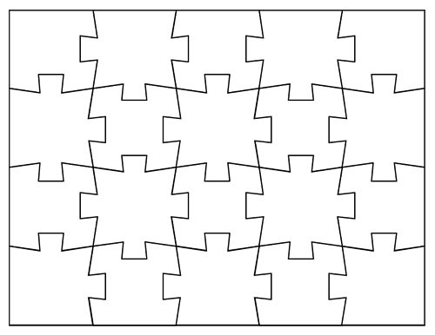
Can you link all 15 poems? Write a short quotation from one poem on a piece and then add a quotation from each poem in the anthology in another piece – the challenge is to make them ‘fit’ together in some way.

