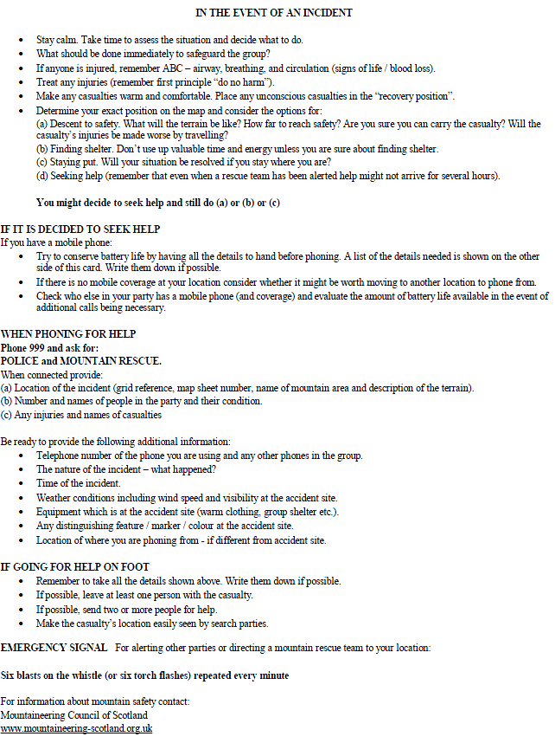 **Telephone Emergency Procedures**

**IN THE EVENT OF AN INCIDENT**

1. Use your mobiles to phone **Mrs Neilson** on 07500602509

**If no contact is made…**

1. Use your mobiles to phone **Mr Bones on 016977 45393**

**If no contact is made…**

1. Find the nearest phone box and phone **Mrs Neilson** on 07500602509

**If no contact is made…**

1. Using the phone box to phone **Mr Bones on 016977 45393**

**If no contact is made and the incident is serious…..**

1. Phone 999 and ask for Police and Mountain Rescue
2. **If you cannot contact any of the above or need to inform your assessor of any changes please phone Amy Finnie on 07900800109 or 07768104001**