## **A Christmas Carol**

**STAVE 1: Setting the scene**

**“solitary as an oyster”**

**“he was all in a glow”**

**“I wear the chain I forged in life”**

**“Are there no prisons?”**

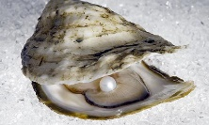 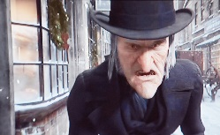 **CONTRAST 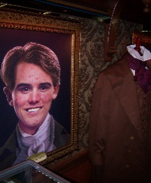 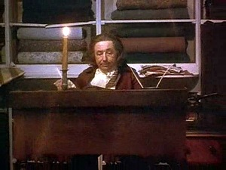 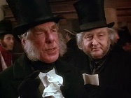 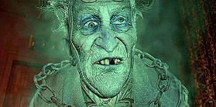 NARRATIVE DISRUPTION**

“There was a boy singing a Christmas Carol at my door last night. I should like to have given him something: that’s all.”

**STAVE 2:** **Ghost of Christmas Past**

**“a solitary child”**

**“another idol has displaced me…a golden one”**

**“home’s like heaven”**

**“a lonely boy was reading by a feeble fire”**

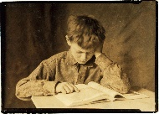 village schoolhouse  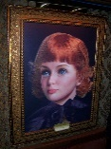 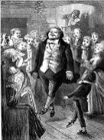 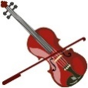 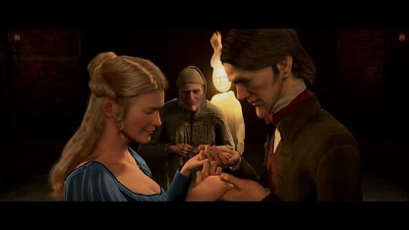 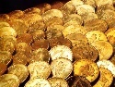

**“remove me! I cannot bear it!”**

STAVE 3: **Ghost of Christmas Present**

**“This boy is Ignorance. This girl is Want”**

**“a jolly giant…who bore a glowing torch”**

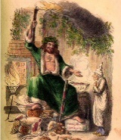 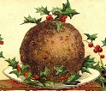 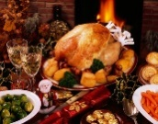 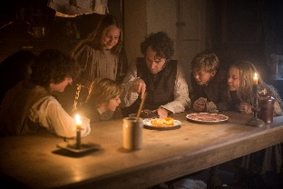 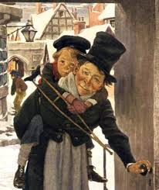 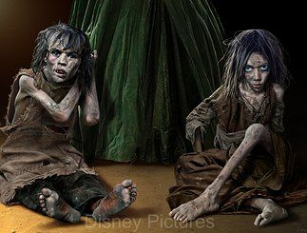

**“If these shadows remain unaltered by the Future, the child will die”**

**“Are there no prisons?” – Ghost uses Scrooge’s words.**

**“I see a vacant seat by the corner”**

**STAVE 4:** **Ghost of Christmas Yet to Come**

**“No spirit! Oh no, no!”**

**“unwatched, unkept, uncared for was the body of this man.”**

**“The Phantom slowly, gravely, silently approached”**

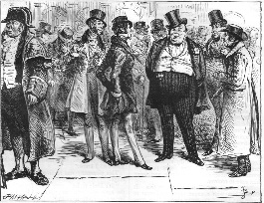 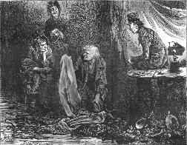 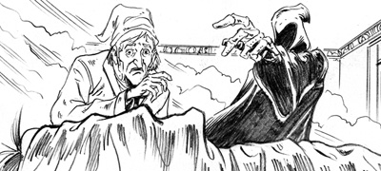 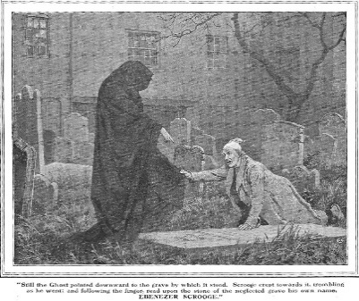 **EPIPHANY**/ **CLIMAX**  **STAVE 5: Redemption – Scrooge is transformed**

**“I am as light as a feather, I am as happy as an angel, I am as merry as a schoolboy!”**

**“I will honour Christmas in my heart and try to keep it all the year!”**

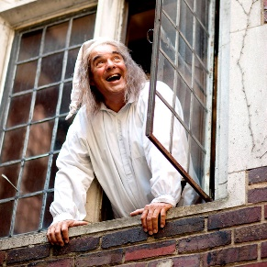   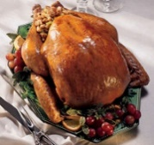   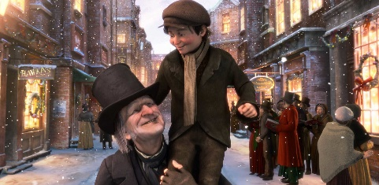

**“to Tiny Tim who did not die, he was a second father!”**

**“Golden sunlight; Heavenly sky!”**